Mentor Mr. Trịnh Ngọc Văn

Team member

Nguyễn Bắc Giang

Nguyễn Thanh Thủy

Phạm Quốc Hoàng

Nguyễn Hoàng Nam

Nguyễn Đặng Thái Sơn

Trần Bùi Thành

Restaurant Chain Management

T2208E - SEMESTER 4 – TEAM 3



TABLE OF CONTENTS

I. Introduction 2

II. Objectives 2

III. Abstract 3

IV. Project Plan 4

V. Use Case 6

VI. Customer Requirement Specification. 8

VII. Requirements 10

VIII. Database Diagram 15

IX. Algorithms and Technology 17

X. UI/UX User Guide 21

XI. Developer’s Guide 57

XII. Check List 60

XIII. Acknowledgments 61

# Introduction

The **Restaurant Chain Management Project** aims to develop a centralized management system for a restaurant chain located in Hanoi. This system will include both web and mobile platforms, streamlining operational processes, order management, delivery services, and customer experience.

With chain management capabilities, the system will assist managers in monitoring each branch in detail, from updating stock status and overseeing service quality to managing personnel. The **inner-city delivery feature** will enable real-time order tracking, efficient management of delivery staff, and order status notifications for customers.

The system will support the following key features:

* **Order Management:** Enables quick and efficient tracking and processing of customer orders.
* **Branch Management:** Allows managers to track revenue, costs, and operational efficiency of each branch.
* **Inner-city Delivery Service:** Delivery services are managed by in-house delivery staff, ensuring quality and timely delivery.
* **Customer Interaction:** The app will enable customers to book tables, order online, and track order status, providing a convenient and seamless experience.

The restaurant chain management system will optimize operational efficiency, reduce errors, enhance customer experience, and bring consistency to managing the restaurant chain.

# Objectives

The primary objectives of the **Restaurant Chain Management Project** are to build a robust and user-friendly system that enhances operational efficiency, improves customer satisfaction, and supports scalable growth. The key objectives include:

1. **Streamline Operations Across Branches**

Implement centralized control for all branches, enabling real-time monitoring and standardized processes across the chain to ensure consistency and quality.

1. **Enhance Order and Delivery Management**

Provide a seamless order processing and delivery system with real-time tracking, order status updates, and optimized delivery routes, improving the efficiency of in-house delivery services.

1. **Improve Customer Experience**

Create a user-friendly platform for customers to place orders, track delivery status, and interact with each branch conveniently. The system should provide a smooth experience that enhances customer loyalty and retention.

1. **Data-driven Insights for Better Decision-making**

Enable data collection and analytics for key performance metrics such as sales, customer feedback, and delivery times. These insights will assist managers in making informed decisions to improve service quality and branch performance.

1. **Optimize Resource Allocation**

Implement features to track and manage inventory, workforce, and financial resources effectively, reducing wastage and ensuring resource availability across branches.

1. **Scalable Design for Future Expansion**

Design the system to support potential future expansion, allowing for new branches or cities to be added with minimal setup. The system should be flexible and scalable to adapt to the company’s growth strategy.

By achieving these objectives, the **Restaurant Chain Management Project** aims to establish a competitive advantage, ensuring high-quality service, operational excellence, and a seamless experience for both customers and staff across all locations.

# Abstract

The **Restaurant Chain Management Project** is designed to create a comprehensive web and mobile application system to streamline the management of a restaurant chain based in Hanoi. By centralizing the operations, order processing, and delivery services within a single platform, this project aims to improve operational efficiency, ensure consistency across branches, and enhance customer experience.

This system will enable real-time monitoring and control over multiple branches, providing tools for managers to track inventory, sales, and employee performance seamlessly. Integrated delivery services allow for real-time order tracking and effective management of in-house delivery personnel, ensuring timely and reliable service within Hanoi's urban area.

Furthermore, the platform will offer customers a convenient interface for ordering, booking, and receiving order updates, which not only improves satisfaction but also builds loyalty. Through analytics and data-driven insights, the project will empower decision-makers to optimize resource allocation, predict demand, and identify areas for operational improvement.

With scalability at its core, the **Restaurant Chain Management Project** is built to support the future expansion of the chain, ensuring that additional branches can be smoothly integrated. This project aims to position the restaurant chain as a leader in service quality, operational excellence, and customer-centric solutions in Hanoi.

# Project Plan

**• Determine the project goals to be achieved - Project Goal.**

The project aims to automate and optimize the management of a restaurant chain in Hanoi, improving efficiency in operations, order processing, and delivery services within Hanoi's urban area.

**• Determine project deliverable time – Project Deliverable.**

* **Project Start Date:** October 4, 2024
* **Project Evaluation:** November 1, 2024
* **Project Submission Date:** November 15, 2024

**• Determine the project roadmap - Project Schedule.**

1. **Introduction**
   * Summarize the challenges of managing a multi-branch restaurant chain, difficulties in handling delivery logistics, and propose ideas for a centralized management system to streamline operations and improve service quality.
2. **Plan**
   * Develop a project implementation plan divided into **4 sprints**, each lasting **1 week**.
     + **Sprint 1:** Set up foundational architecture, define main modules, and establish database structure.
     + **Sprint 2:** Implement key features for branch management and order processing.
     + **Sprint 3:** Integrate delivery management feature, ensuring real-time order tracking and customer notifications.
     + **Sprint 4:** Finalize user interface, optimize performance, and conduct testing for quality assurance.
   * **Task Assignment:** Assign tasks to team members, specifying responsibilities, deadlines, and weekly progress targets.
3. **Analysis - Design**
   * Describe the problem with diagrams:
     + **Stakeholders:** Define roles for each component within the system, including permissions based on roles.
     + **Use-case Diagrams:** Outline user interactions with each major feature.
     + **Flowchart:** Illustrate the flow of order processing, from placement to delivery.
     + **Process Diagram (sequence):** Show sequences of core processes such as order handling and delivery dispatch.
     + **ERD (Entity-Relationship Diagram):** Define entities such as Branch, Order, Delivery, Customer, etc.
4. **Supporting Plans - Supporting Plans**
   * **Human Resource Plan:** Define roles (e.g., Project Manager, Developer, UI/UX Designer, Quality Assurance), and assign specific tasks and workloads.
   * **Communication Plan:** Establish channels for sharing updates and documentation with team members and stakeholders.
   * **Risk Management Plan:** Identify potential risks (e.g., underestimating time, incomplete tasks, or difficulties in workload distribution) and define preventive or corrective actions.
5. **Project Implementation**
   * **Task Sheet:** List detailed tasks for each function to complete the above flows. Include fields for **Function name**, **Description**, **Input**, **Output**.
   * **Testcase Documentation:** Add a **Success/Fail** column to the task sheet to report items that function correctly or require revision.
6. **Technology used in the project**
   * Specify the **algorithms** and **technologies** for database management, backend, and frontend development.
   * Outline requirements for **server configuration** and **deployment technology** (e.g., cloud services, hosting requirements).
7. **Results**
   * Describe the main features of the system with screenshots, showcasing key functionalities like order processing, delivery tracking, and customer management.
8. **Conclusion & Development Direction**
   * Discuss achievements, unresolved aspects, challenges encountered, and future development directions for the project, such as expanding to more cities or adding advanced analytics for better business insights.

# Use Case

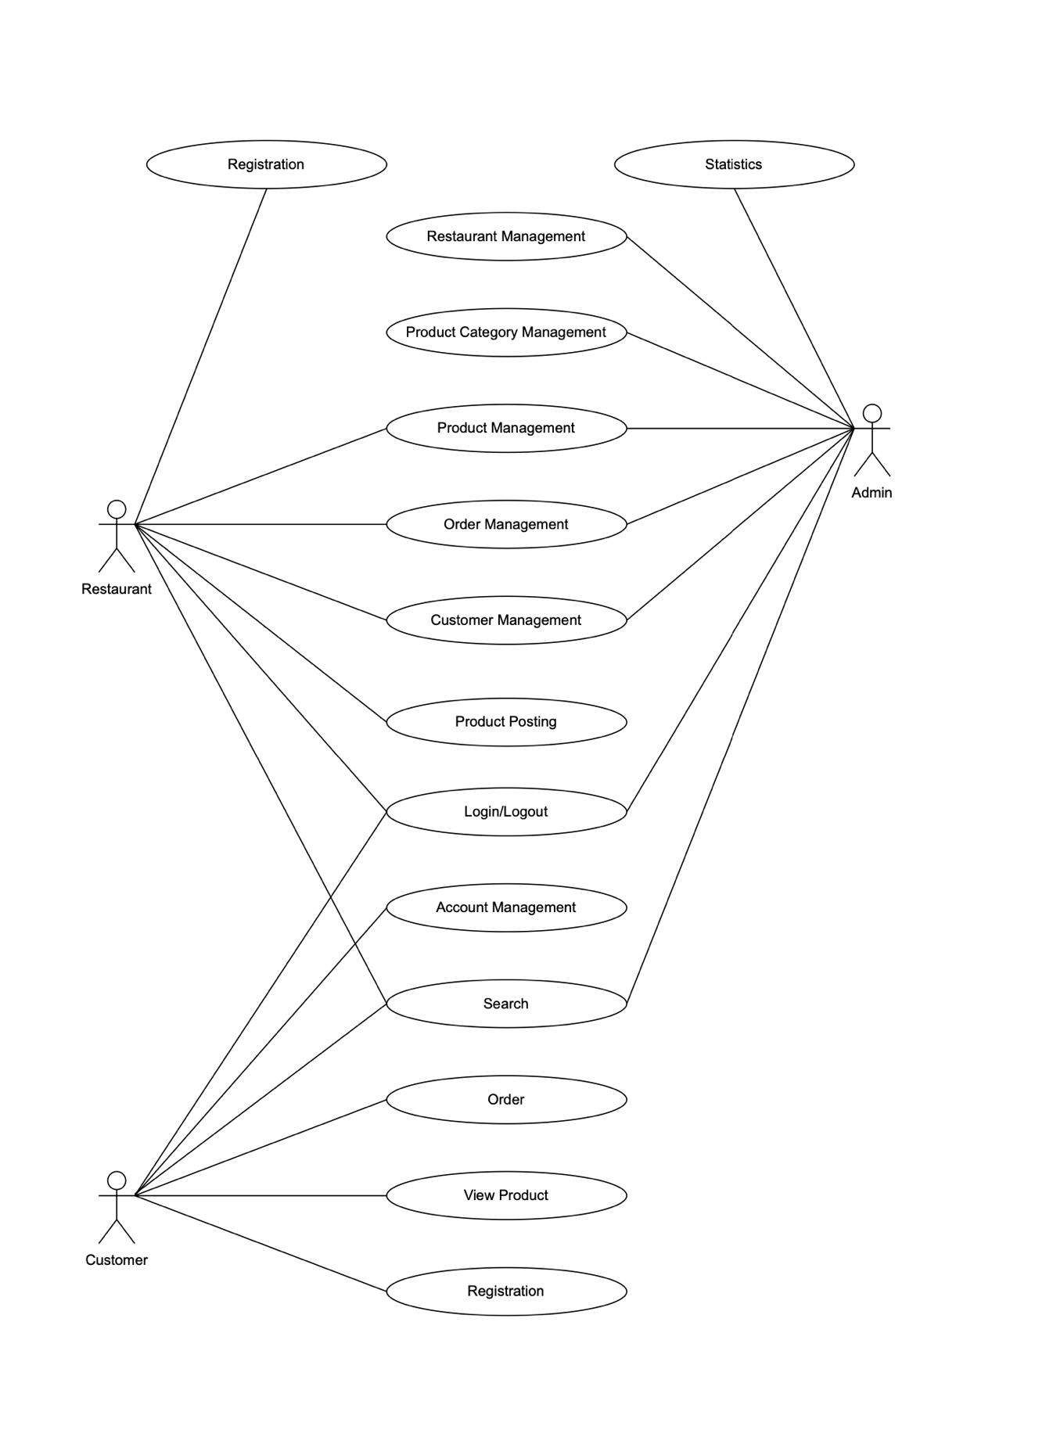

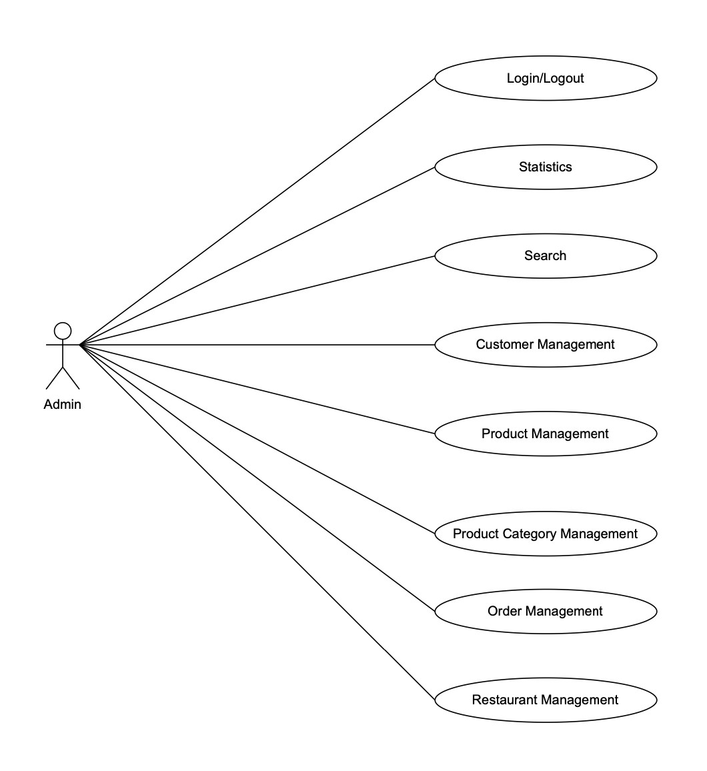

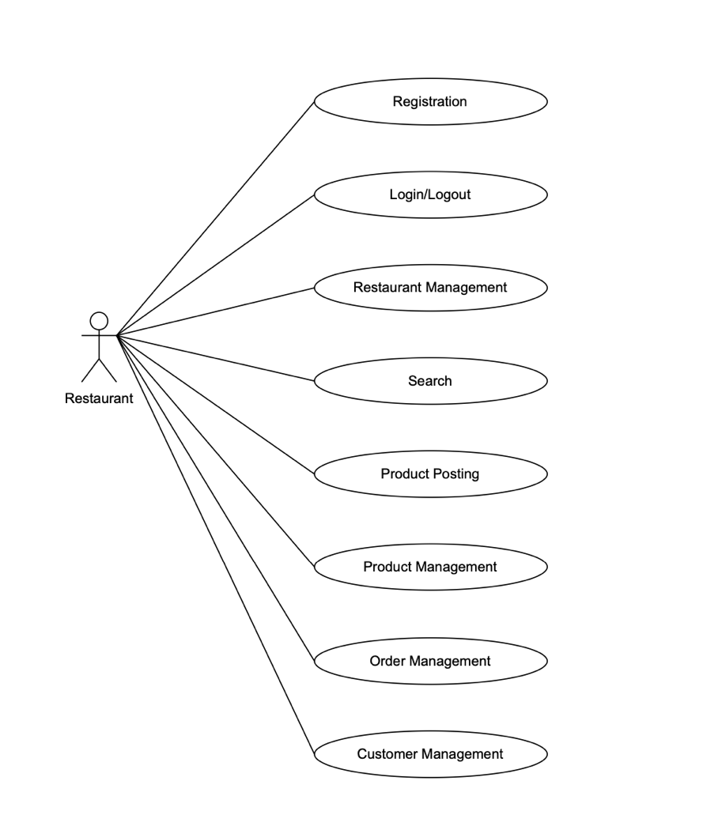

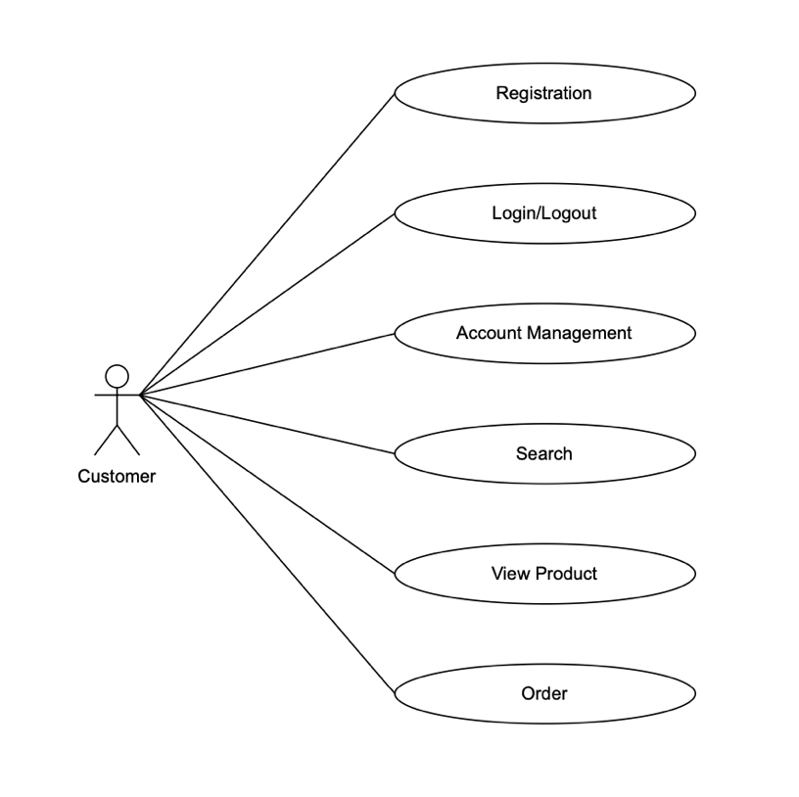

# Customer Requirement Specification.

There will be 3 types of users

* Guest
* Customer
* Admin

1. Guest

Guest users will be able to browse website, read about the information and see the products. But guest users will not be able to do shopping.

1. Customer
   * Register with the system
   * Name
   * Address
   * Phone Number
   * Customer can login with unique user name and password.
   * He can change the password.
   * Can purchase the policy online: For purchasing the policy online, he has to fill in the application form which would capture all the required information about the vehicle. On successful payment, copy of policy would be generated which customer can save for the records.
   * Initiate the claim by filling the claim form.
2. Admin

* Employee will be admin who can login with admin user name and password.
* He can perform all the admin functions as maintaining the policy records, claim records, payment schedules etc
* Following reports needs to be generated
  + Monthly sell of policies
  + Vehicle wise analysis
  + Claims report
  + Policies due renewals
  + Policies lapsed report

1. The site should have menu categorising required functionalities

* About us
* Types of insurance
* Testimonials
* Site map
* Contact us

1. There should be a categorized menu.
2. Data should be properly paginated while showing the products.
3. The site should have a professional look and feel.

# Requirements

**MODULE DESCRIPTION**

## **5.1) MODULE 1: LOGIN**

Login module allows only authorized user to access the system.

## **5.2) MODULE 2: CUSTOMER INFORMATION**

In this module, system stores customer’s information in database.

***Customer Record***

This table contains the following information:

*Fields Description*

**Customer ID Numeric**

**Customer Name Character**

**Customer ADD Character**

**Customer phone number Numeric**

## **5.3) MODULE 3: VEHICLE INFORMATION**

In this module, system stores vehicle’s information in database.

***VEHICLE Information***

This table contains the following information.

***Fields Description***

**Vehicle Id Numeric**

**Vehicle name Character**

**Vehicle’s owner name Character**

**Vehicle model Character**

**Vehicle version Character**

**Vehicle Rate Numeric**

**Vehicle body number Character**

**Vehicle engine number Character**

**Vehicle number Numeric**

## **5.4) MODULE 3: ESTIMATE**

This module generates estimates for the Vehicle insurance enquired by customer. Estimate module will have customer’s information from Customer Information Module 2.

***Estimate***

**This table contains the following information**

***Fields Description***

**Customer ID Numeric**

**Estimate number Numeric**

**Customer name Character**

**Customer phone number Numeric**

**Vehicle name Character**

**Vehicle model Character**

**Vehicle Rate Numeric**

**Vehicle warranty Character**

**Vehicle policy type Character**

## **5.5) MODULE 4: INSURANCE PROCESS**

This module, customer takes vehicle insurance from company. System maintains the records in database. This module is related to Customer Information Module 2.

***Customer policy Records***

**This table contains the following information**

***Fields Description***

**Customer ID Numeric**

**Customer Name Character**

**Customer ADD Character**

**Customer phone number Numeric**

**Policy number Numeric**

**Policy date Character**

**Policy duration Numeric**

**Vehicle number Numeric**

**Vehicle name Character**

**Vehicle model Character**

**Vehicle version Character**

**Vehicle Rate Numeric**

**Vehicle warranty Character**

**Vehicle body number Character**

**Vehicle engine number Character**

**Customer Add Prove Character**

## **5.6) MODULE 5:** **COMPANY BILLING POLICY**

This module, generate the customer bill and store its payment detail with date, bill number and car information policy number. This module is related to module 2.

***Customer Billing Information***

**This table contains the following information**

***Fields Description***

**Customer ID Numeric**

**Customer Name Character**

**Policy number Numeric**

**Customer Add Prove Character**

**Customer phone number Numeric**

**Bill No. Numeric**

**Vehicle name Character**

**Vehicle model Character**

**Vehicle Rate Numeric**

**Vehicle body number Character**

**Vehicle engine number Character**

**Date Character**

**Amount Numeric**

## **5.7) MODULE 8: REPORT**

In this module, generate the report of company monthly insurance and income and customer report.

## **5.8) MODULE 9: COMPANY EXPENSES**

In this module, store the showroom expenses. Expenses type, expenses amount, expenses date.

***Company Expenses***

**This table contains the following information**

***Fields Description***

**Date of Expense Character**

**Type of Expense Character**

**Amount of Expense Numeric**

## **5.9) MODULE 10: CLAIM DETAILS**

**In this module the details of the claims initiated and approved are maintained.**

***Claim Details***

**This table contains the following information**

**Fields Description**

**Claim Number Numeric**

**Policy Number Numeric**

**Policy Start Date Character**

**Policy End Date Character**

**Customer Name Character**

**Place of accident Character**

**Date of accident Character**

**Insured amount Numeric**

**Claimable amount Numeric**

# Database Diagram

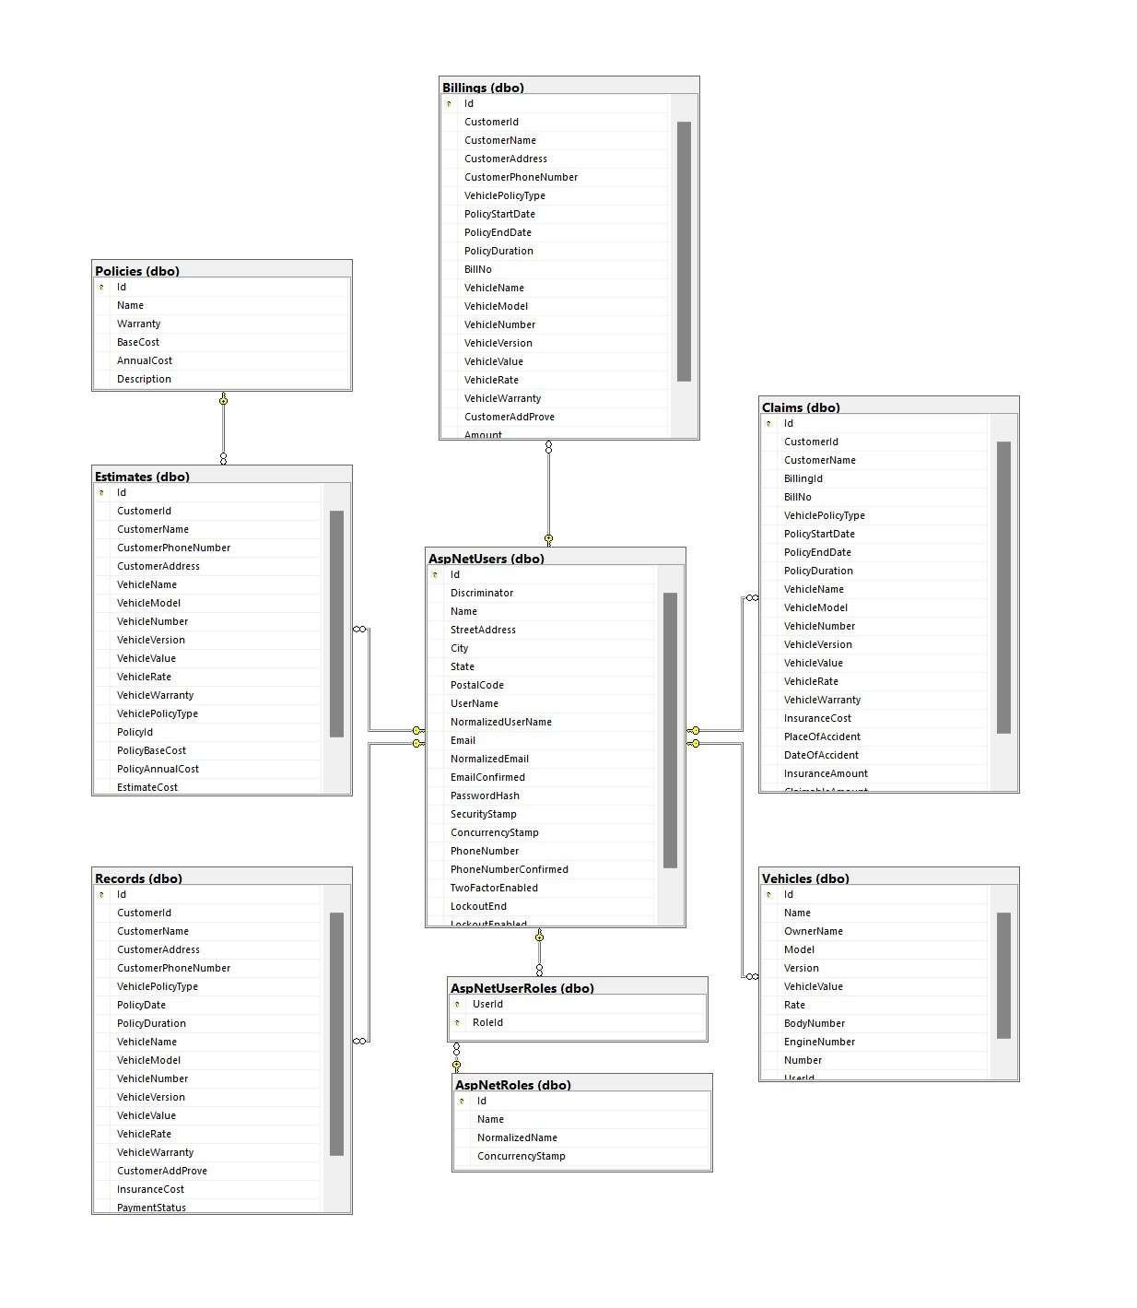

The image depicts a detailed database diagram showcasing the components and processes involved in managing data within a database management system.

The diagram includes several labeled elements, each representing a specific aspect of the database system. These elements are interconnected by arrows, illustrating the flow of data and processes between them.

Some key components visible in the diagram are:

* Data Entry: This component represents the process of entering data into the database system. It could involve user interfaces or automated mechanisms for data input.
* Data Validation: This component focuses on validating the entered data to ensure its accuracy and adherence to predefined rules or constraints. It may involve checking data types, formats, or applying business rules.
* Data Storage: This element represents the storage mechanism where the data is stored within the database system. It could include tables, files, or other data storage structures.
* Data Retrieval: This component refers to the process of retrieving specific data from the database based on criteria or queries. It involves accessing and extracting data from the storage component.
* Data Manipulation: This element represents the operations performed on the data stored in the database. It can include actions like updating, deleting, or modifying records based on user requirements.
* Data Analysis: This component focuses on analyzing the stored data to gain insights or generate reports. It may involve applying statistical techniques, generating charts or graphs, or running complex queries to extract meaningful information.

The arrows connecting these components indicate the flow of data and processes between them. They represent the sequence and relationships between the different elements within the database management system.

Overall, the database diagram provides a detailed representation of the components and processes involved in managing data within the database management system, illustrating the data flow and relationships between the various components.

# Algorithms and Technology

1. Vehicle insurance calculation formula

(The total cost to pay when purchasing Insurance will be based on the actual value of the vehicle * fee rate, in which:

Actual value of the car = minimum remaining ratio of the minimum quality of the car after being put into use (vehicle rate) * new car price.

The remaining minimum percentage of the vehicle's quality after being put into use (vehicle rate) is determined:

* Newly purchased car: 100% of value
* Vehicle used 1 - 3 years: 85% value
* Vehicle used 3 - 6 years: 70% value
* Vehicles used 6 - 10 years: 55% value
* Vehicles used over 10 years: value 40%

The fee rate is calculated as follows:

* Fee rate = Basic rate (basic range) + additional option fee rate (extended range)
* According to insurance consultants, the basic rate and additional fee options are clearly defined charges in the hazardous compound package. And normally, this fee will range from 1.5% - 2%/year depending on the definition of each hazardous material supplier.)

Based on the information about vehicle insurance we have researched, we have come up with our own vehicle insurance calculation formula:

* Actual insurance price = Basic insurance package price + Vehicle value * Vehicle rate * Number of years the vehicle has been used * Fee rate

Claim calculation formula:

* Claim fee = Actual insurance price * Vehicle rate

1. Search

$('#input-search').on('keyup', function() {

var rex = new RegExp($(this).val(), 'i');

$('.searchable-container .items').hide();

$('.searchable-container .items').filter(function() {

return rex.test($(this).text());

}).show();

});

The JavaScript code snippet is using jQuery to perform a search operation on elements with the class "searchable-container" and the class "items".

The code starts by selecting the elements with the class "searchable-container" and then filters them using the `filter()` function. Within the `filter()` function, a test is performed on each element's text content using the regular expression pattern defined by the variable `rex`. The `rex.test($(this).text())` statement checks if the text content of the current element matches the regular expression pattern.

If a match is found, the element is shown by using the `show()` method. This will make the filtered elements visible on the webpage.

1. Hashing

These mathematical functions take input, called a key, and use it to calculate a fixed-size character string called a hash value. Hashing algorithms transform random-sized data into information that is of a fixed-length value. We use hashing algorithms to perform storage, retrieval, or comparisons in cases where we need to:

* Hash passwords
* Create digital signatures
* Perform data integrity verification

1. MVC ASP.NET 8.0

MVC is a design pattern used to decouple user-interface (view), data (model), and application logic (controller). This pattern helps to achieve separation of concerns. Using the MVC pattern for websites, requests are routed to a Controller that is responsible for working with the Model to perform actions and/or retrieve data. The Controller chooses the View to display and provides it with the Model. The View renders the final page, based on the data in the Model.

The ASP.NET Core MVC framework is a lightweight, open source, highly testable presentation framework optimized for use with ASP.NET Core. ASP.NET Core MVC provides a patterns-based way to build dynamic websites that enables a clean separation of concerns. It gives you full control over markup, supports TDD-friendly development and uses the latest web standards.

ASP.NET gives you a powerful, patterns-based way to build dynamic websites using the MVC pattern that enables a clean separation of concerns. ASP.NET supports many database engines including SQLite, SQL Server, MySQL, PostgreSQL, DB2 and more, as well as non-relational stores such as MongoDB, Redis, and Azure Cosmos DB.

1. Database Microsoft SQL Server

Microsoft SQL Server is a relational database management system. As a database server that stores and retrieves data as requested by other software applications on the same computer or a remote computer using the client-server model. Microsoft provides APIs to access SQL Server over the internet as a web service.

1. JavaScript

* Bootstrap v4.3.1
* jQuery v3.4.1
* Owl Carousel v2.3.4

1. Software

* Visual Studio .Net / ASP
* Microsoft SQL server management studio
* Microsoft Azure
* Jira

Jira is an agile project management tool that supports any agile methodology, be it scrum, kanban, or your own unique flavor. From agile boards, backlogs, roadmaps, reports, to integrations and add-ons you can plan, track, and manage all your agile software development projects from a single tool.

* Zalo, Discord

# UI/UX User Guide

Users open browser and go to the website:

<https://carinsurancemanagerweb20240415190003.azurewebsites.net/>

Guests will be able to browse website, read about the information and see the products. But guests will not be able to do shopping.

1. Home Page

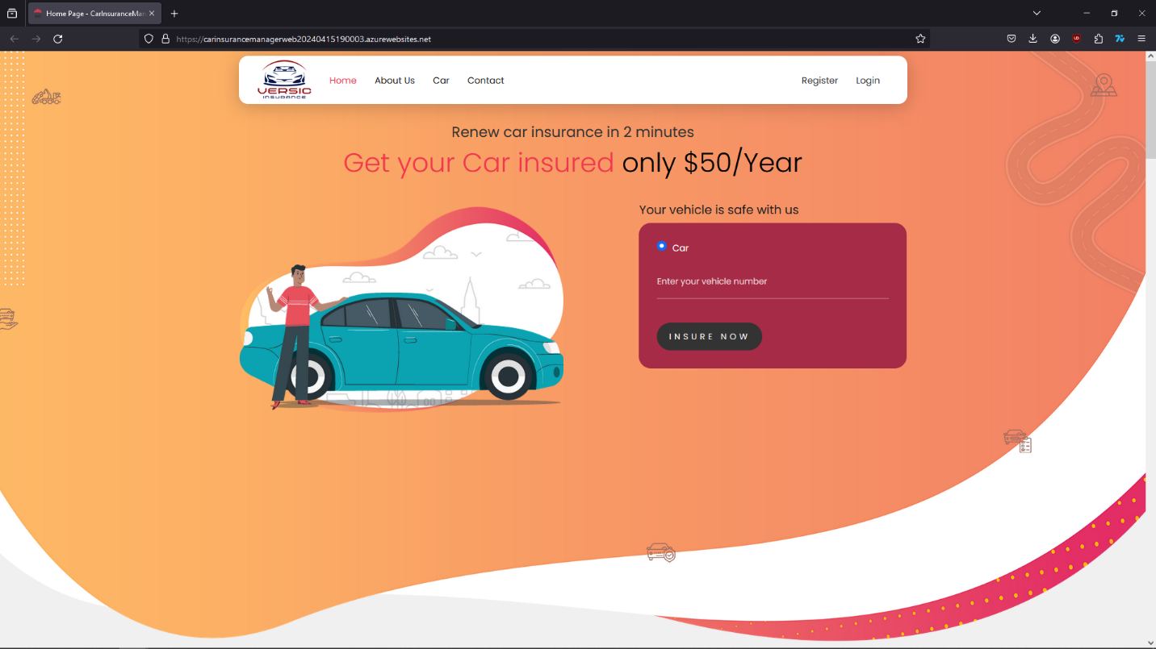

Guests can quickly go to register or log in site by filling out the form and then click the “Insure now” button or keep browsing website.

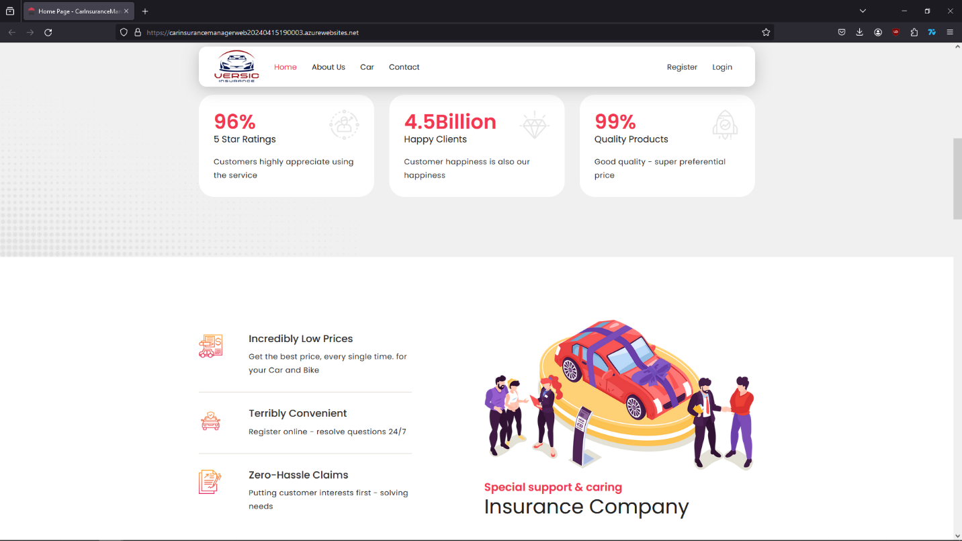

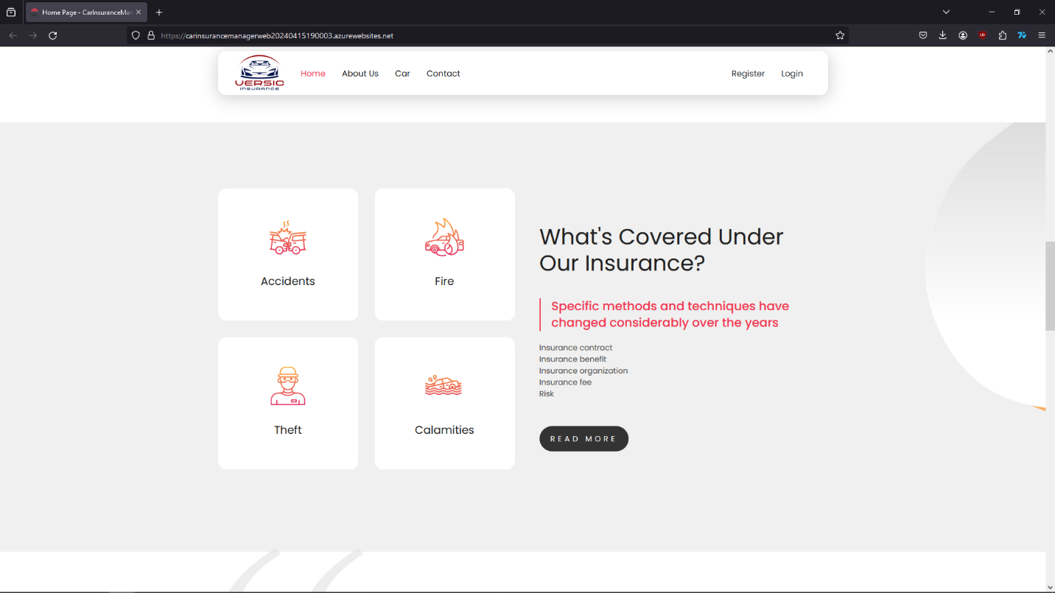

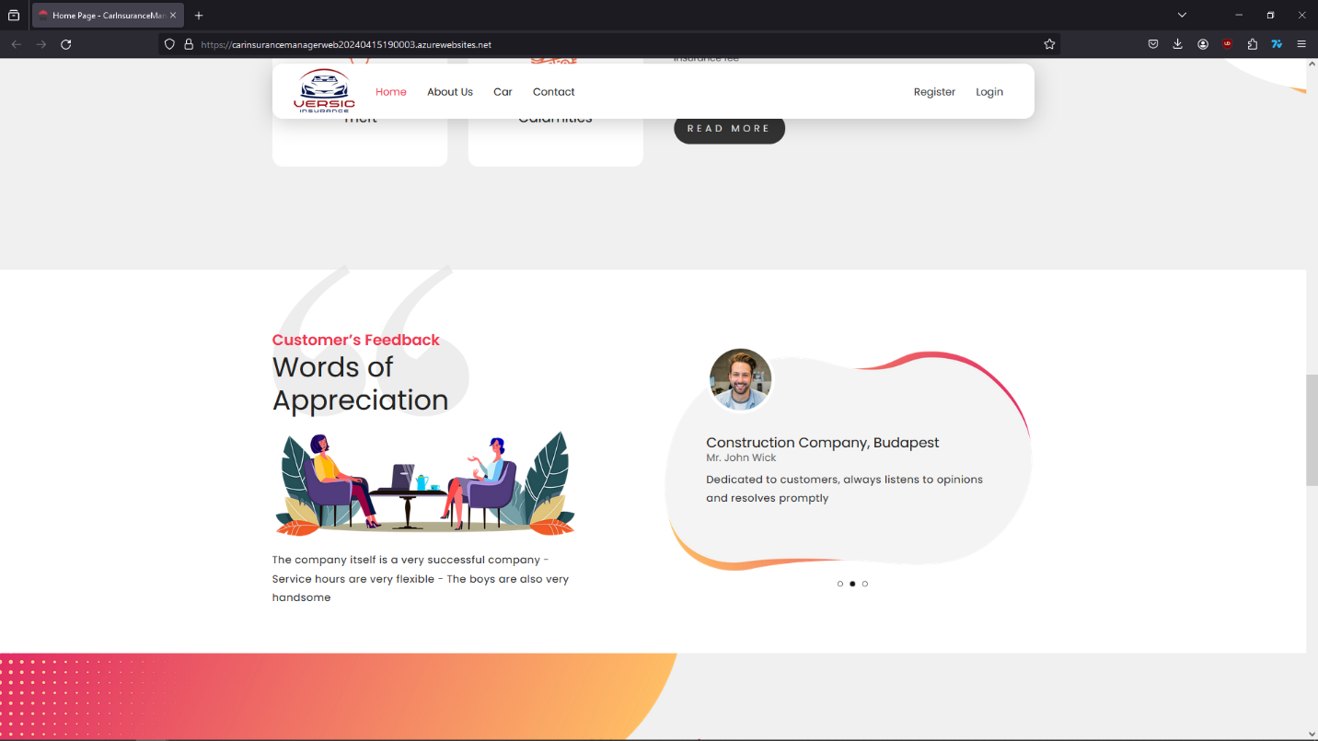

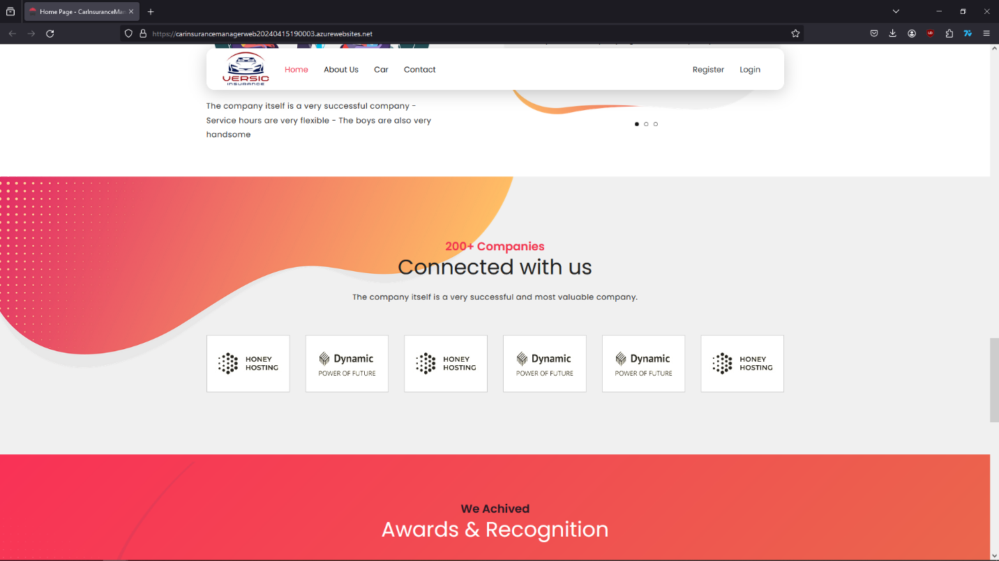

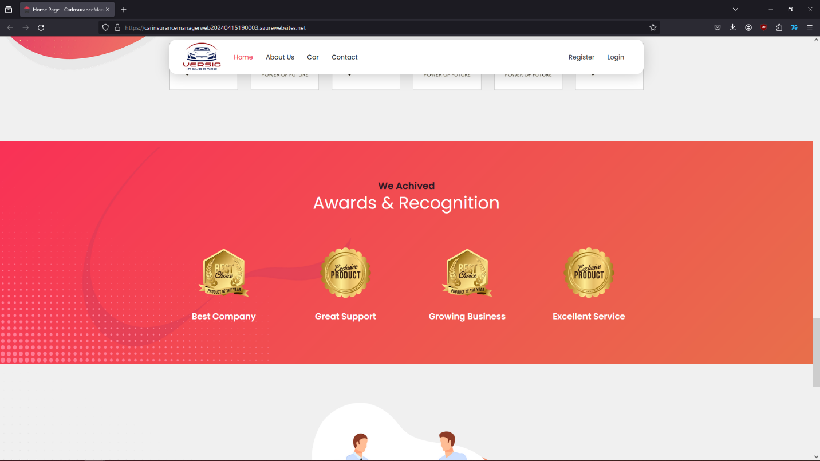

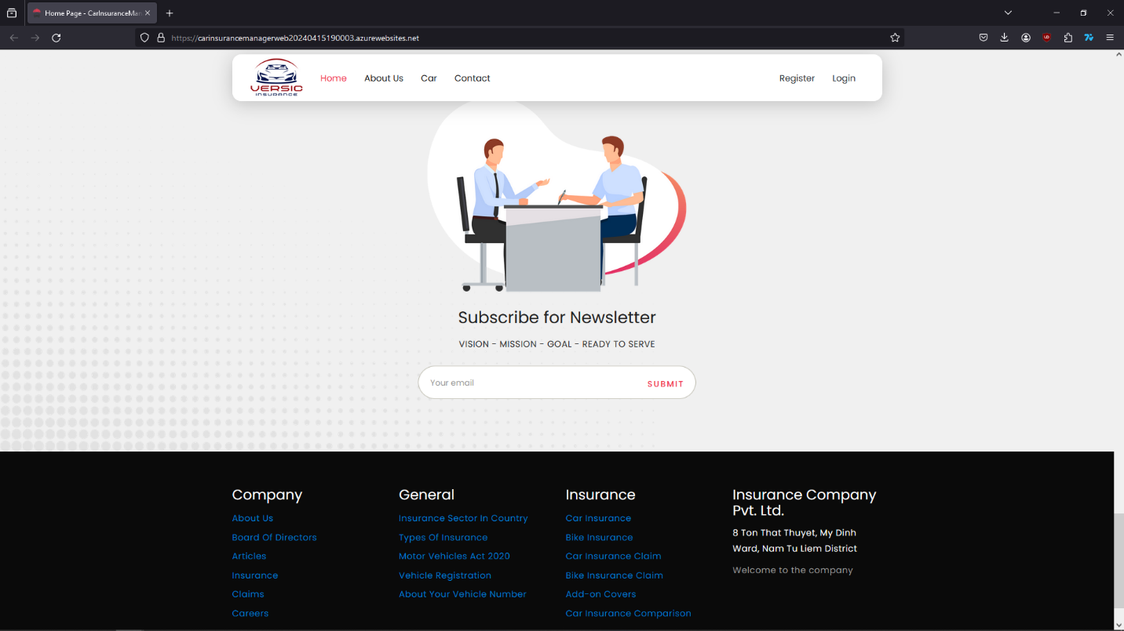

1. About Us

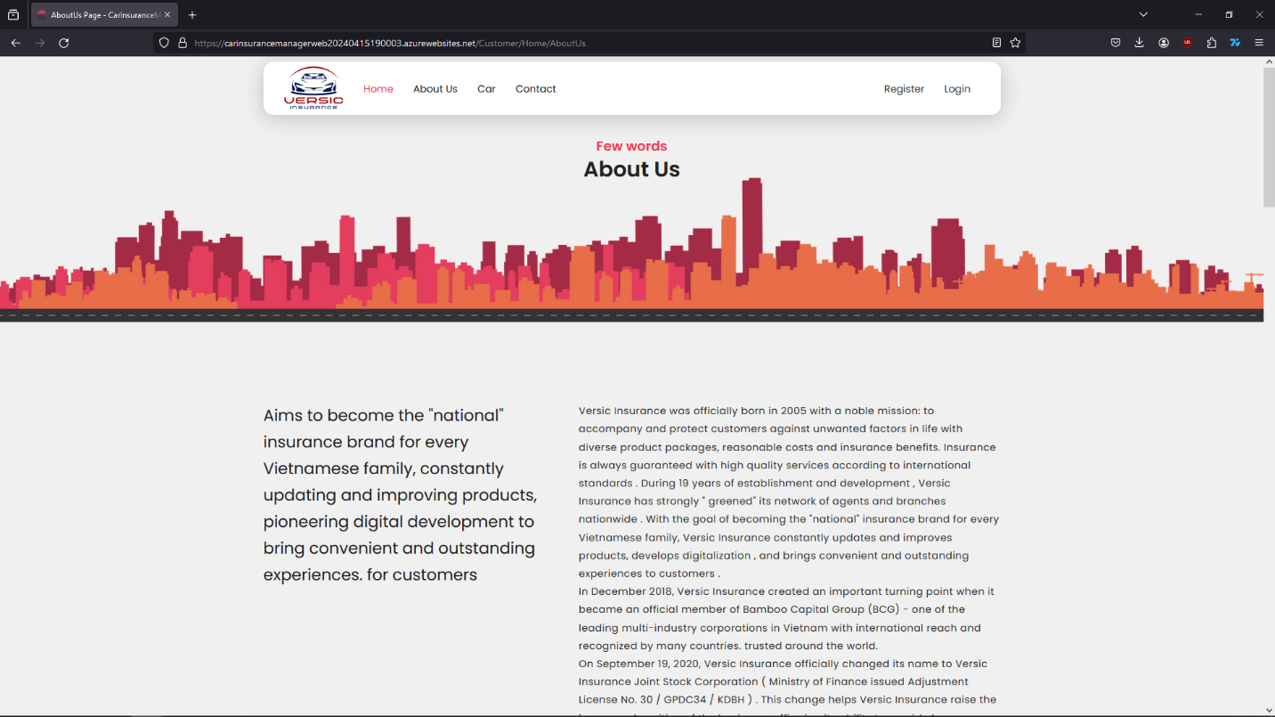

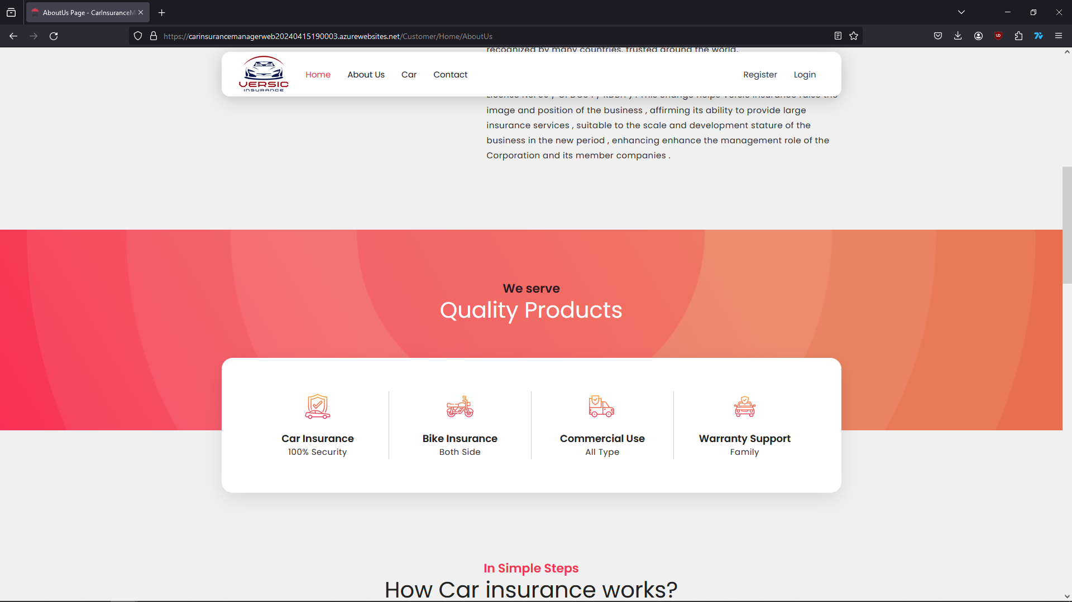

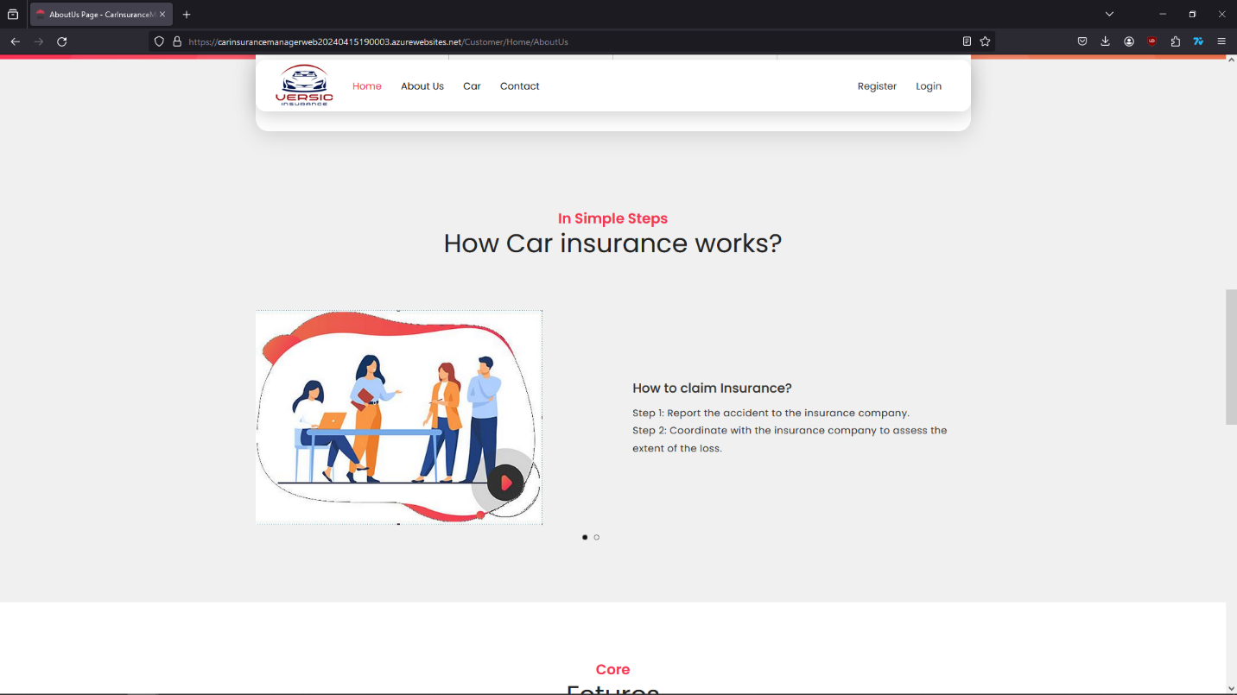

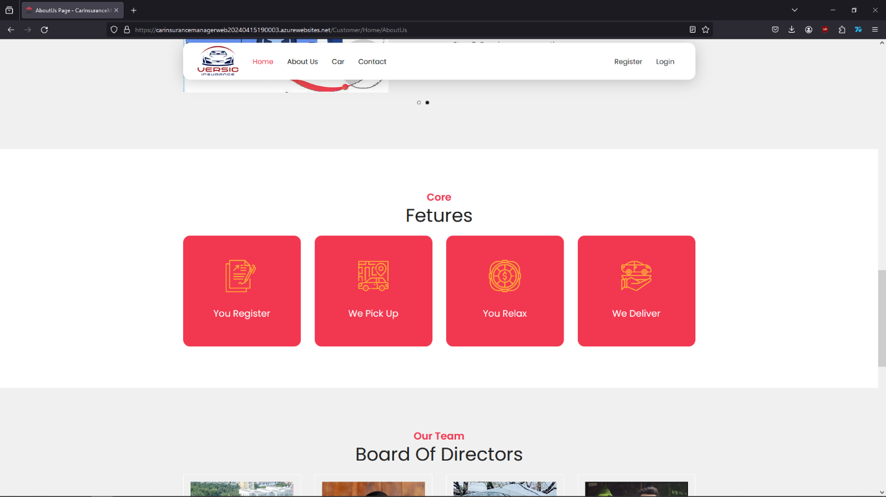

1. Products Site – Types of insurance

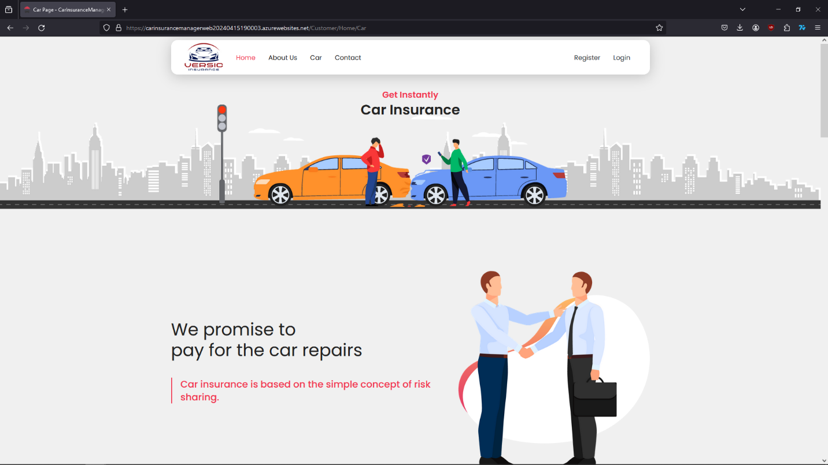

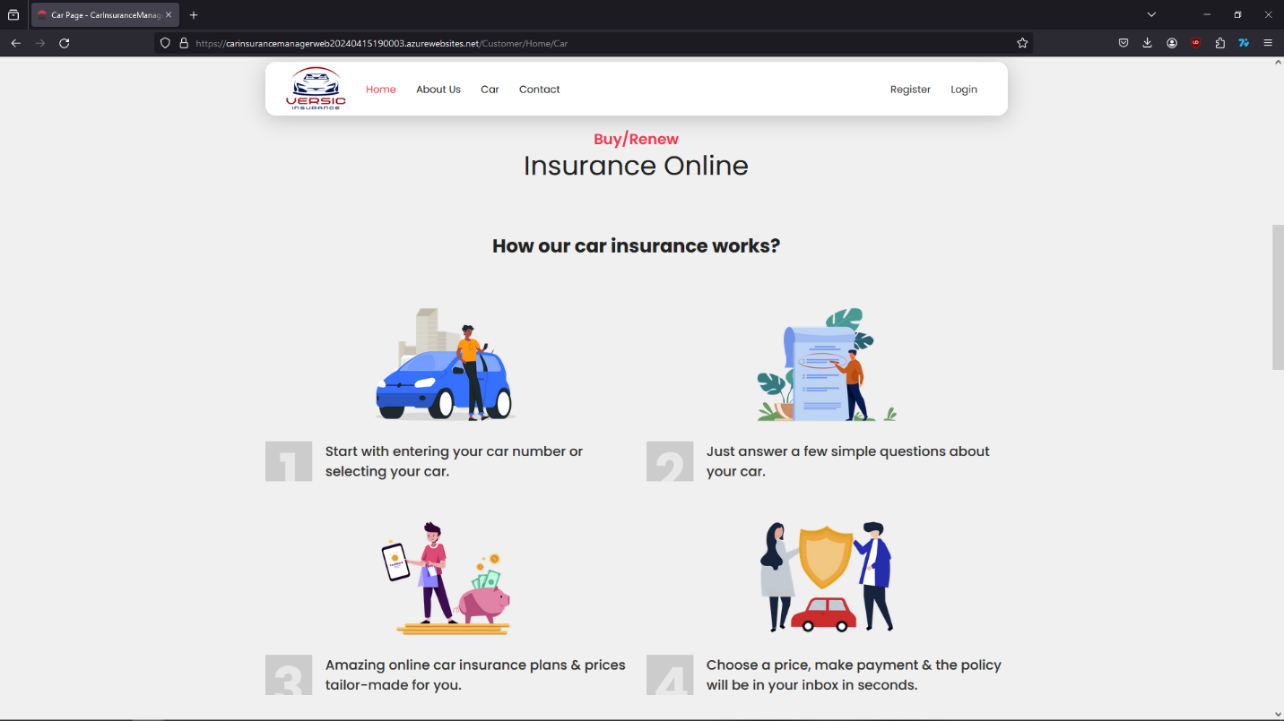

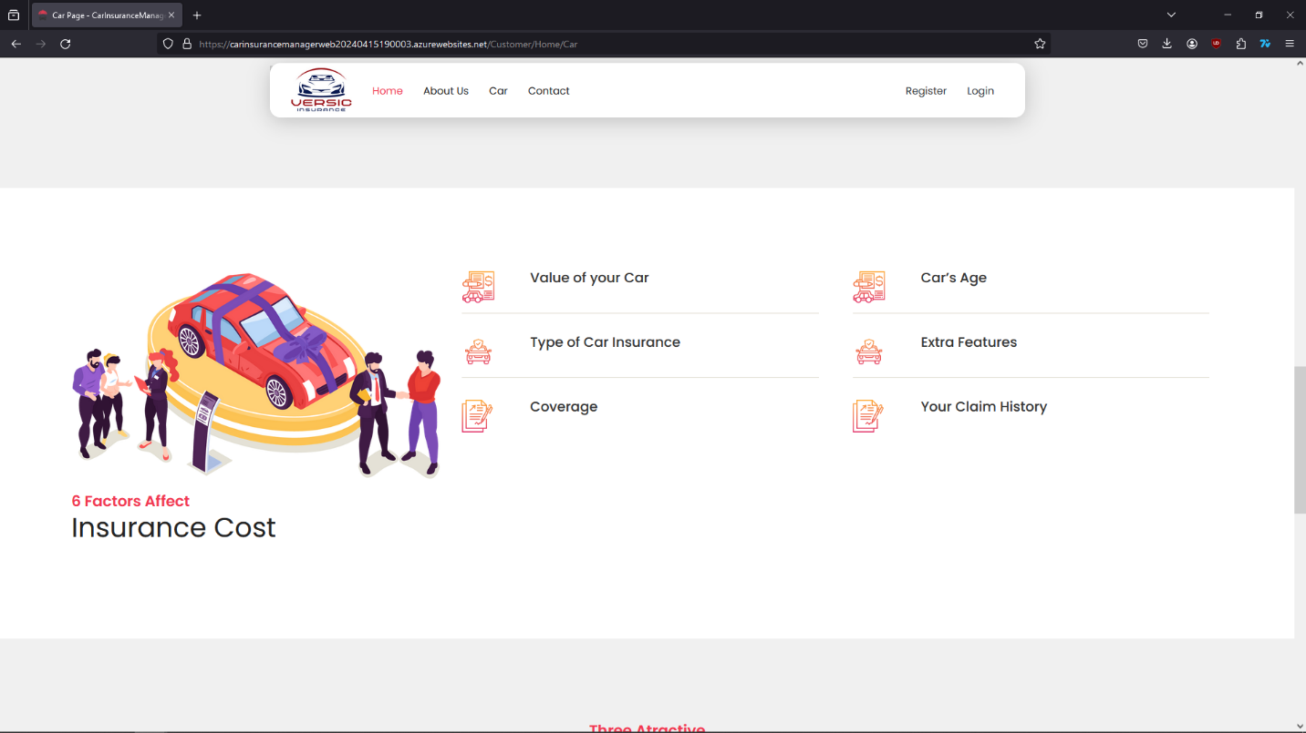

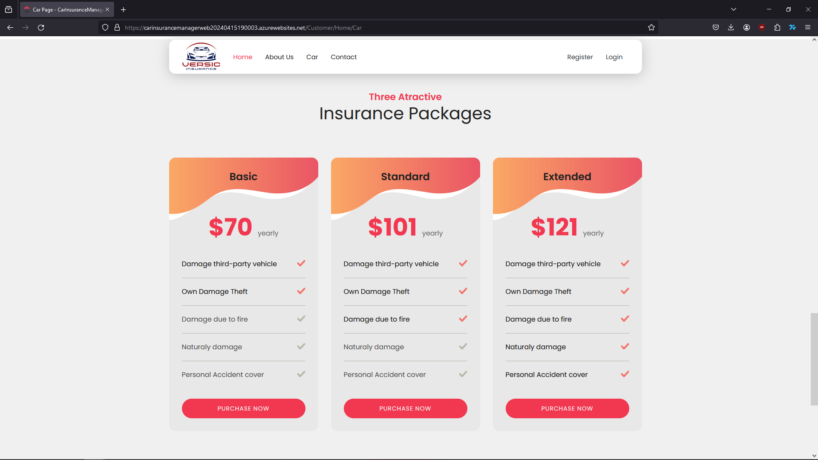

Guests can quickly go to register or log in site by click the “Purchase now” button.

1. Contact Us

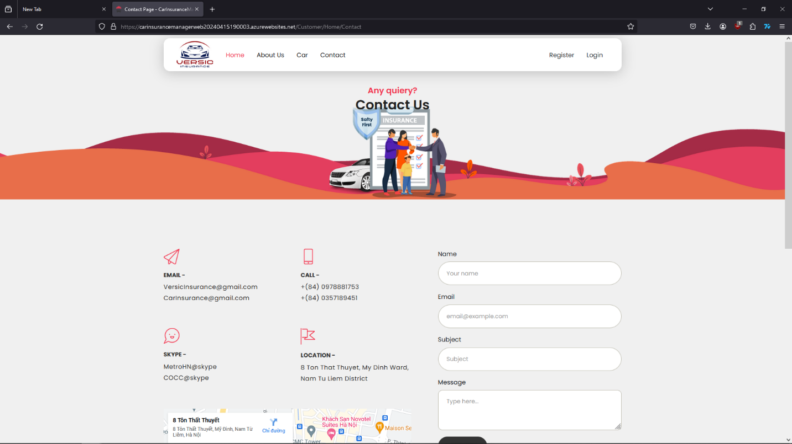

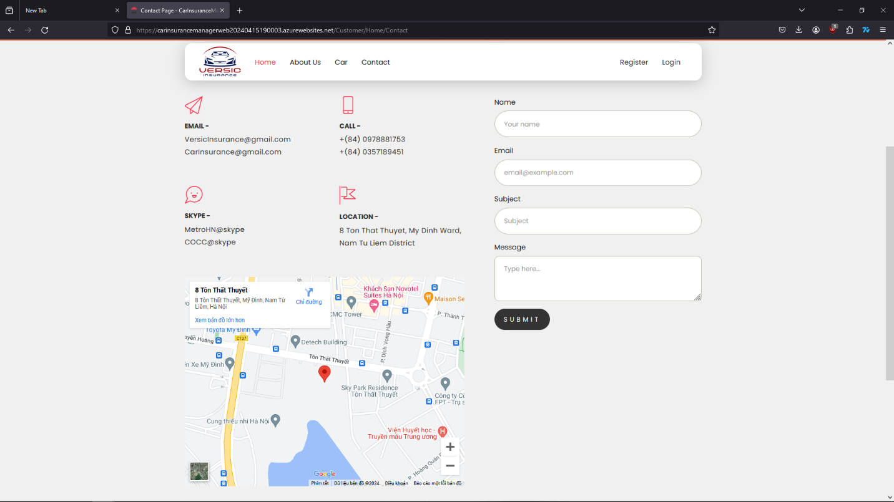

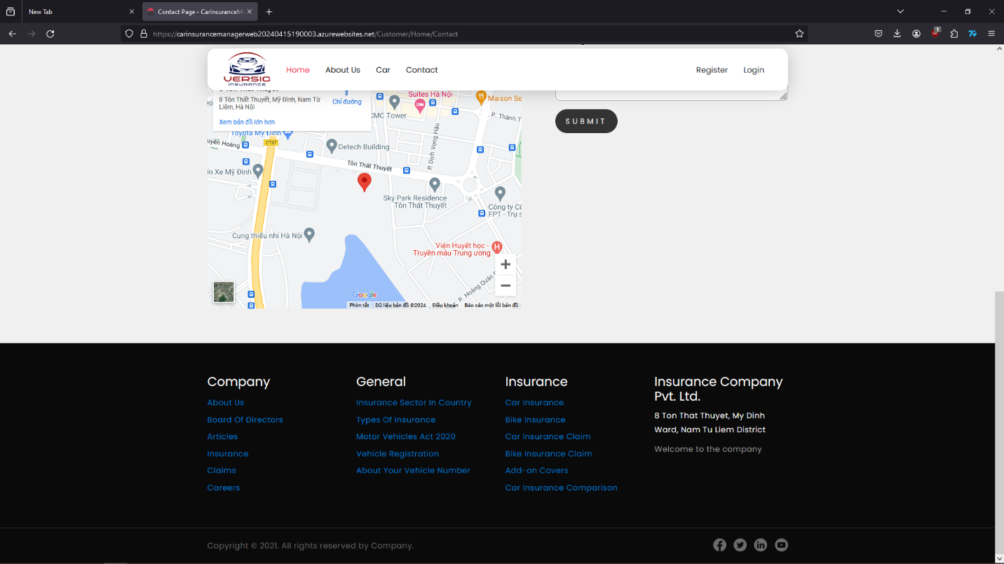

## **CUSTOMER GUIDE**

Guest can click on “Register” button on the navigation bar to make an account and become a customer to start buying products.

1. Register site / Log in site

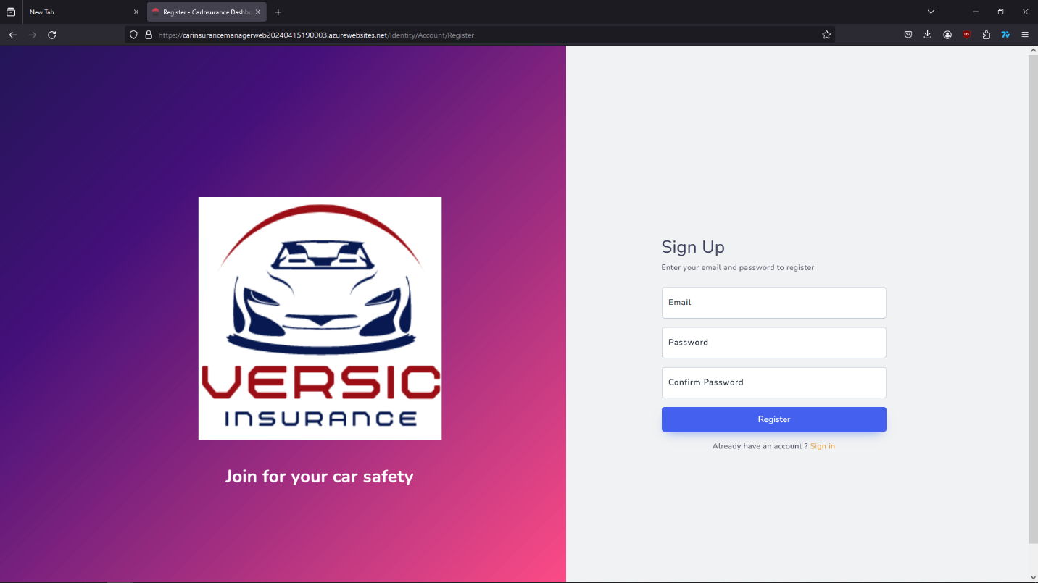

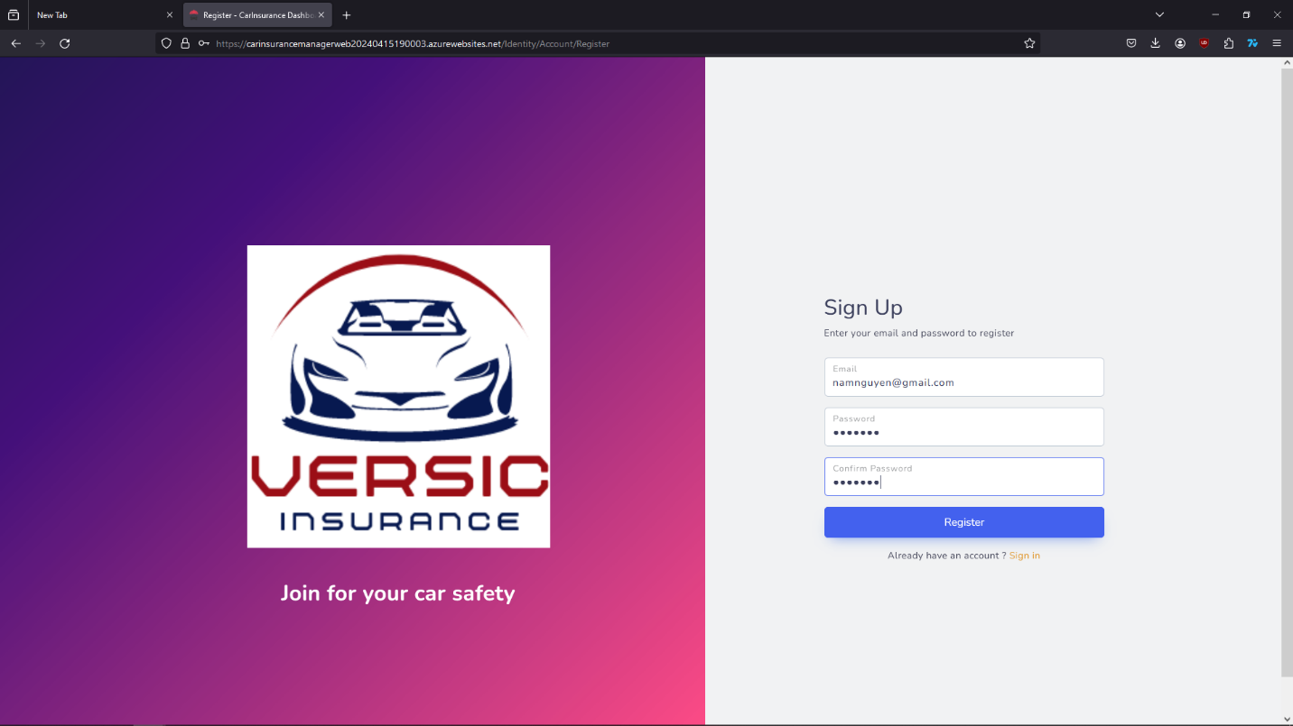

Fill the form with email and create password then press “Register”, very easy, simple and super quick.



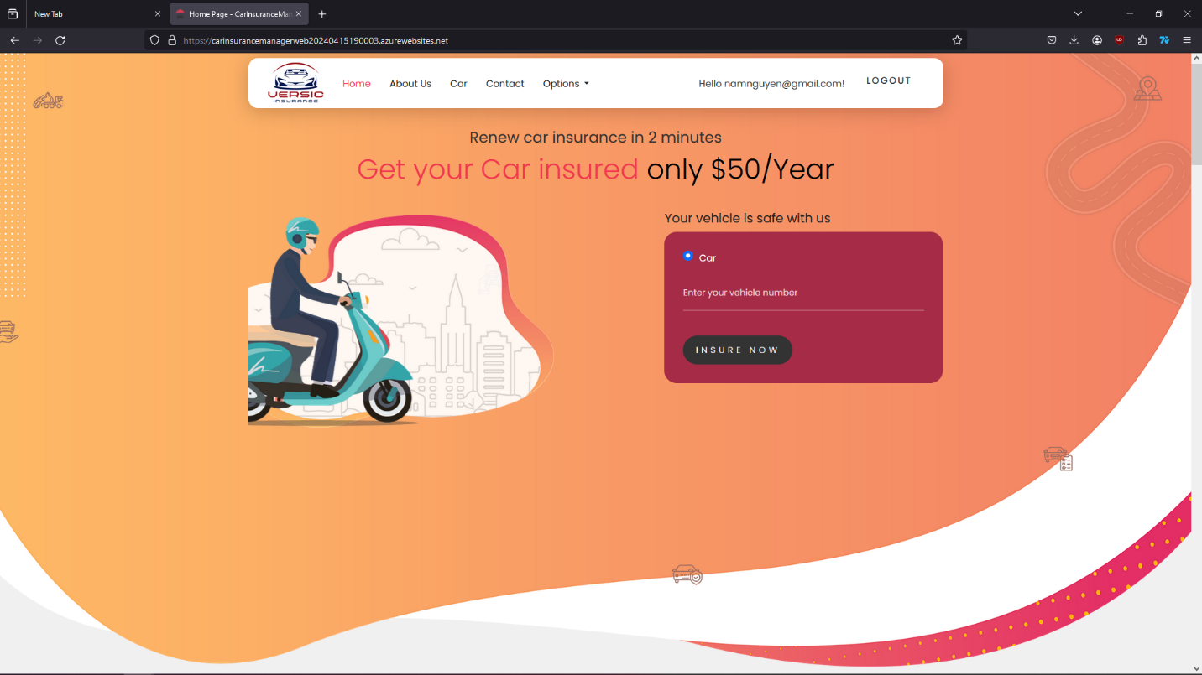

After log in as a customer, they can see the “Option” section on the navigation bar. In the “Option” section customer can buy Insurance, manage their vehicle, calculate the price, manage the record, claim record,…

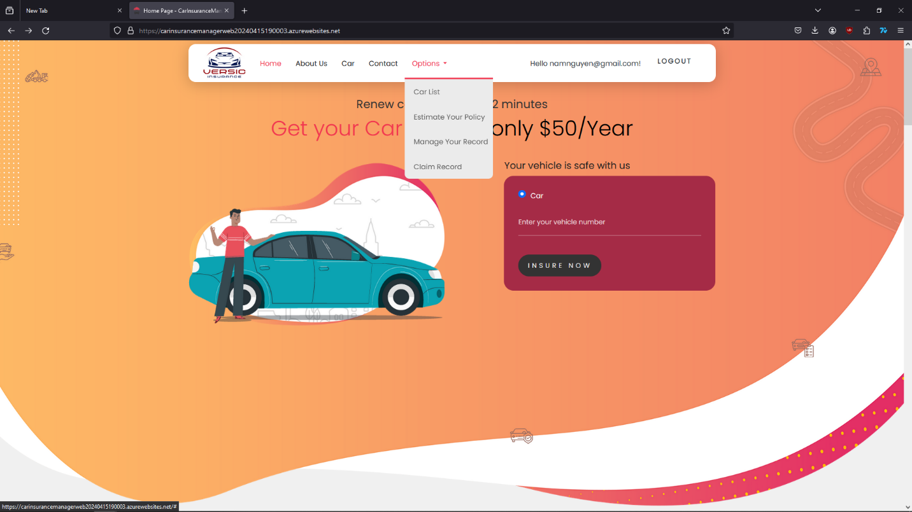

1. Add own vehicle information

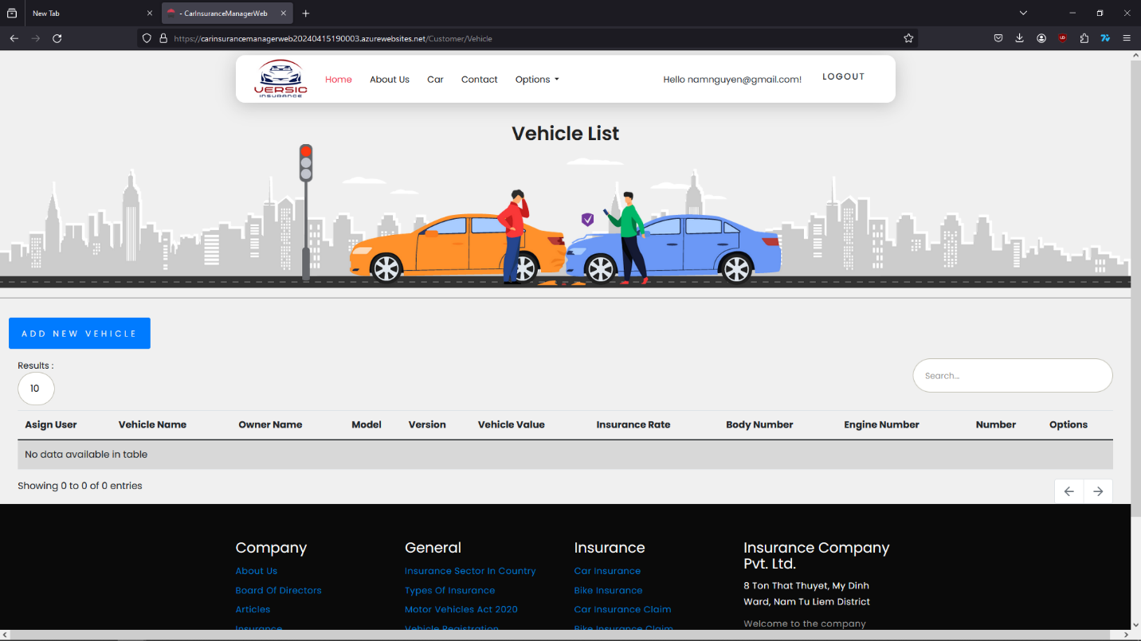

Customer add their own vehicle by press the “ADD NEW VEHICLE” button. Then a form will show up for customer to fill in.

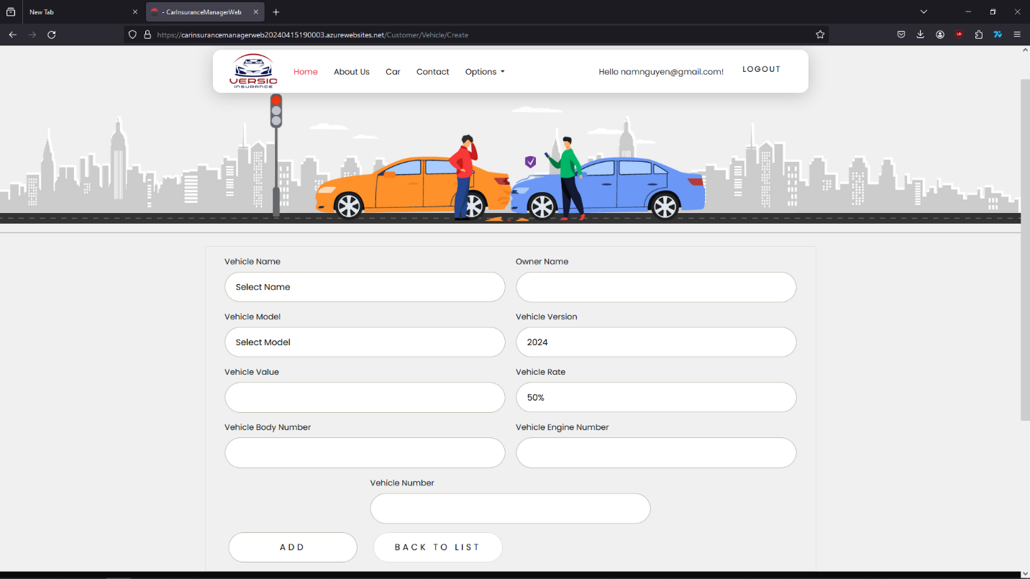

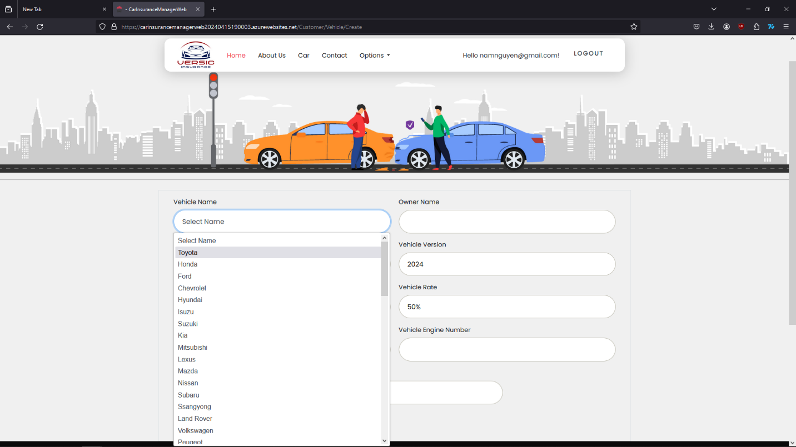

Choose the vehicle brand name, model, vehicle year version, vehicle rate, value of the vehicle, vehicle body number, engine number, owner’s name and license plate.

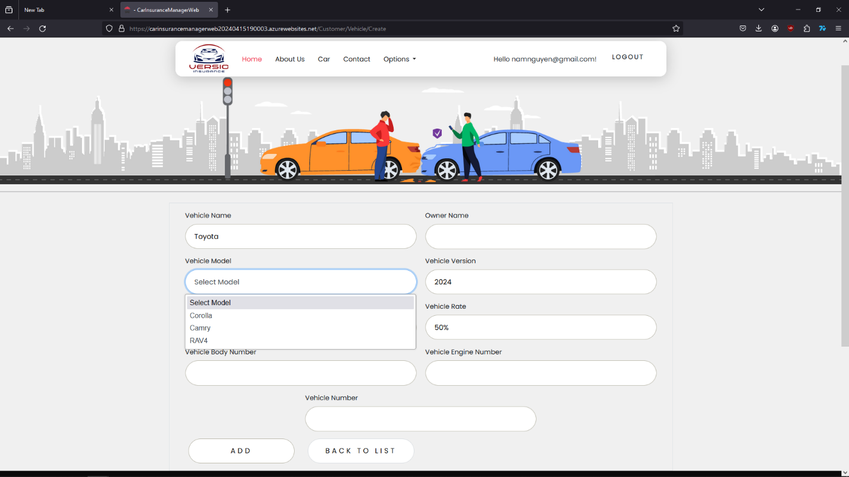

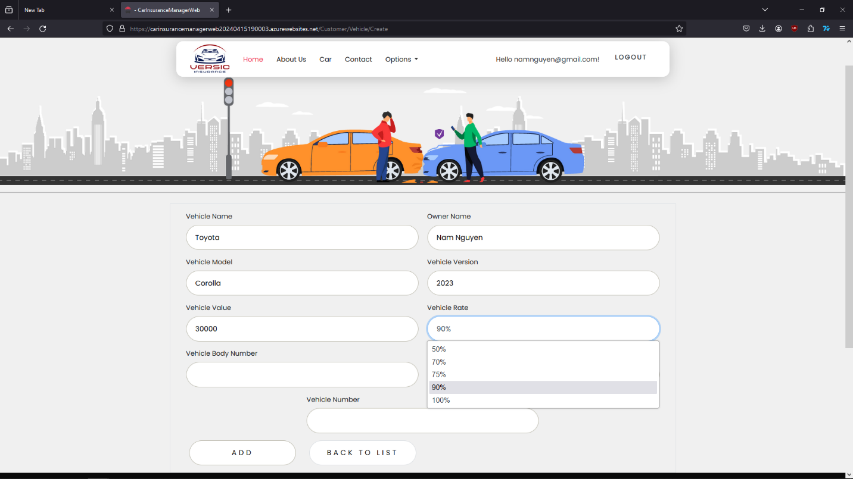

Press the “ADD” button to add the information of the vehicle to the list and start buying Insurance for the vehicle.

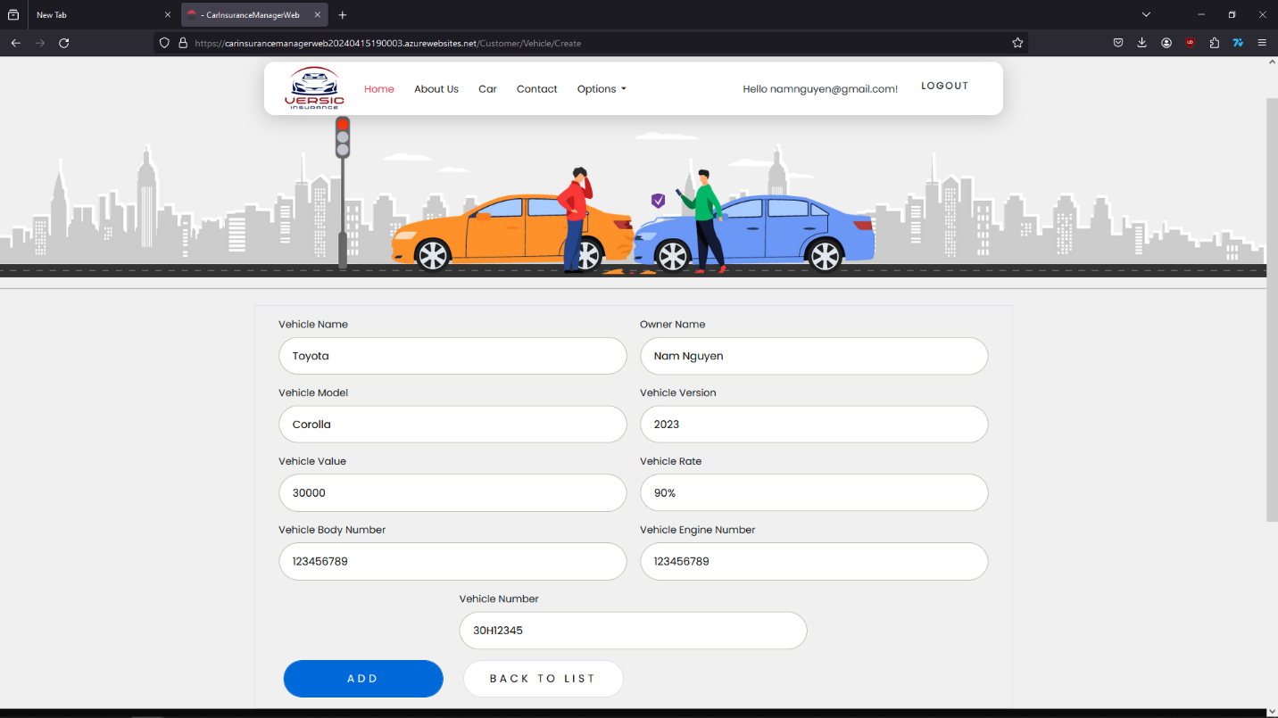

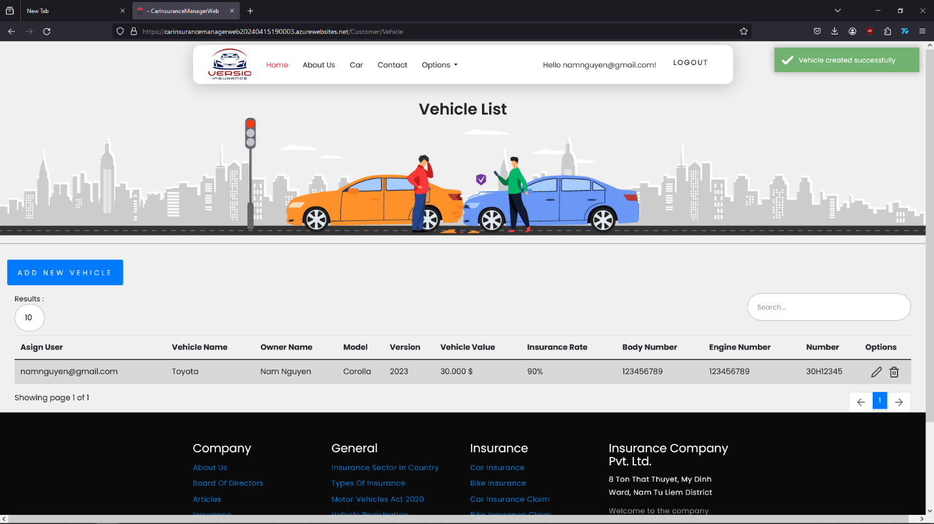

Customer’s vehicle will show on the list. Customer can edit or delete the information. When a customer want to buy Insurance for the vehicle, they can point to “Option” then choose “Estimate Your Policy”.

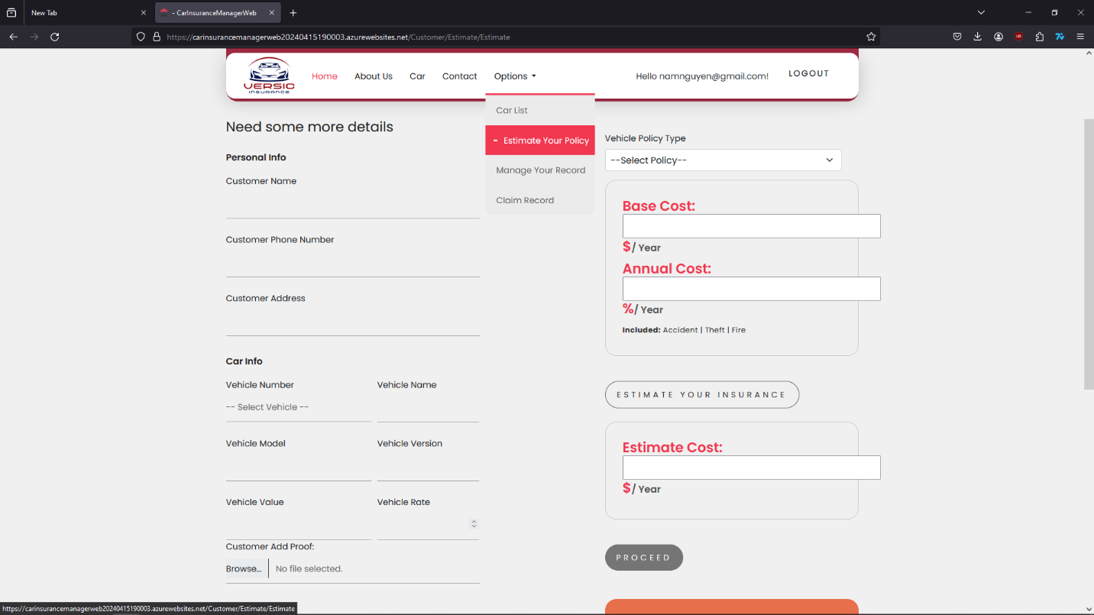

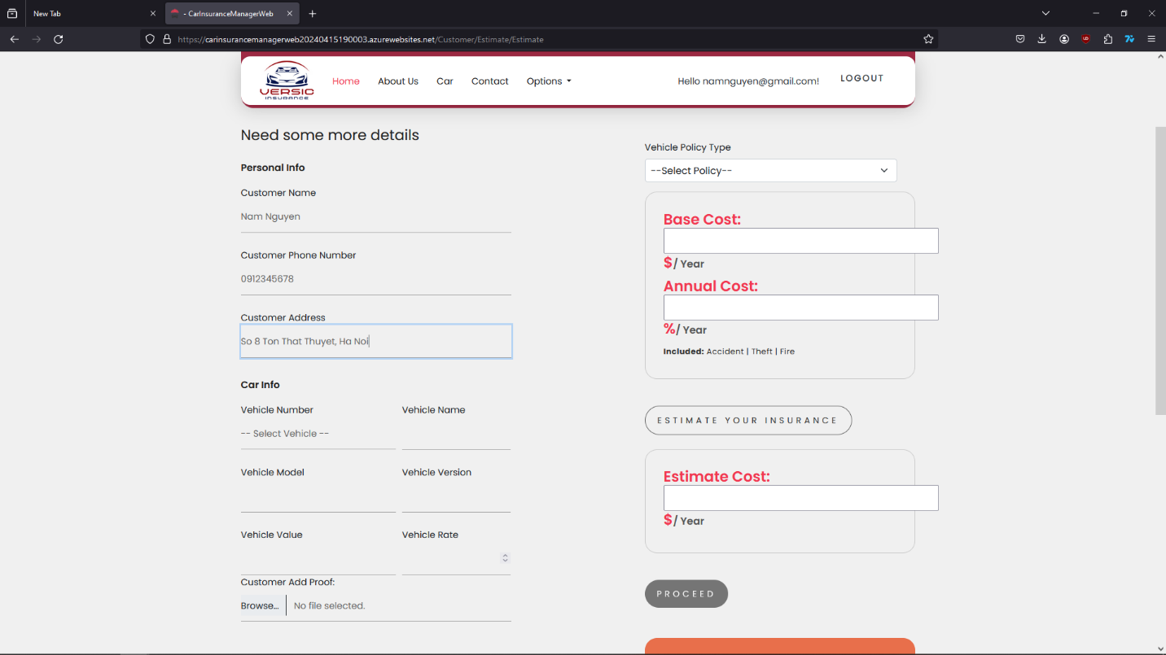

The customer just need to fill in “Personal info”, and choose the vehicle which has been added before.

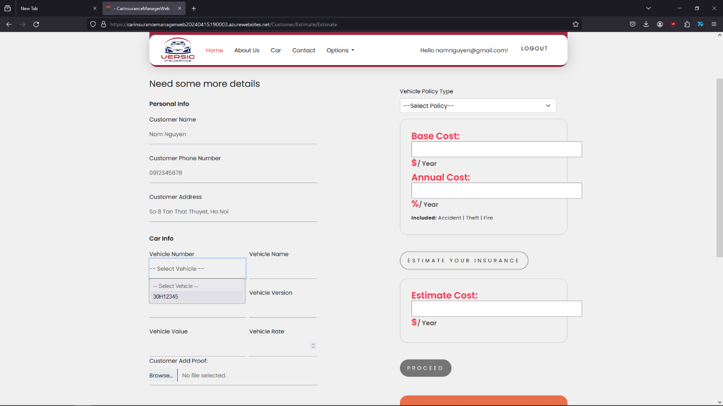

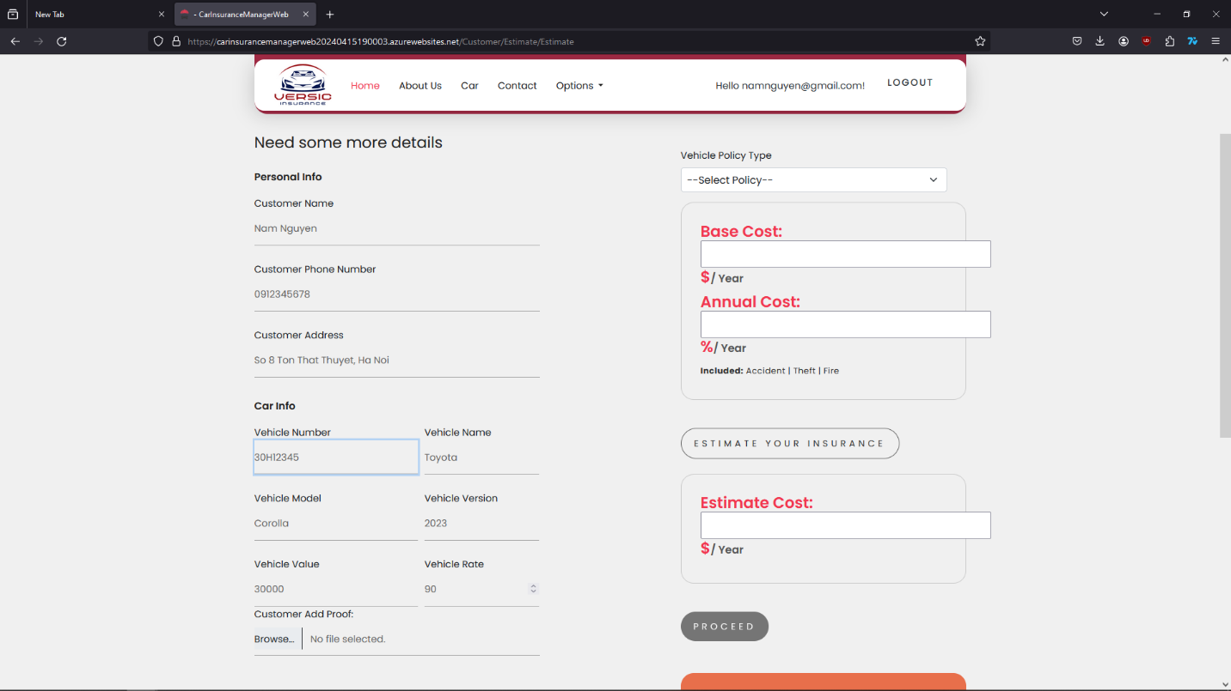

Upload the picture of the vehicle with all the number as the information has been added for checking proof. Then select type of Insurance to start calculating the price.

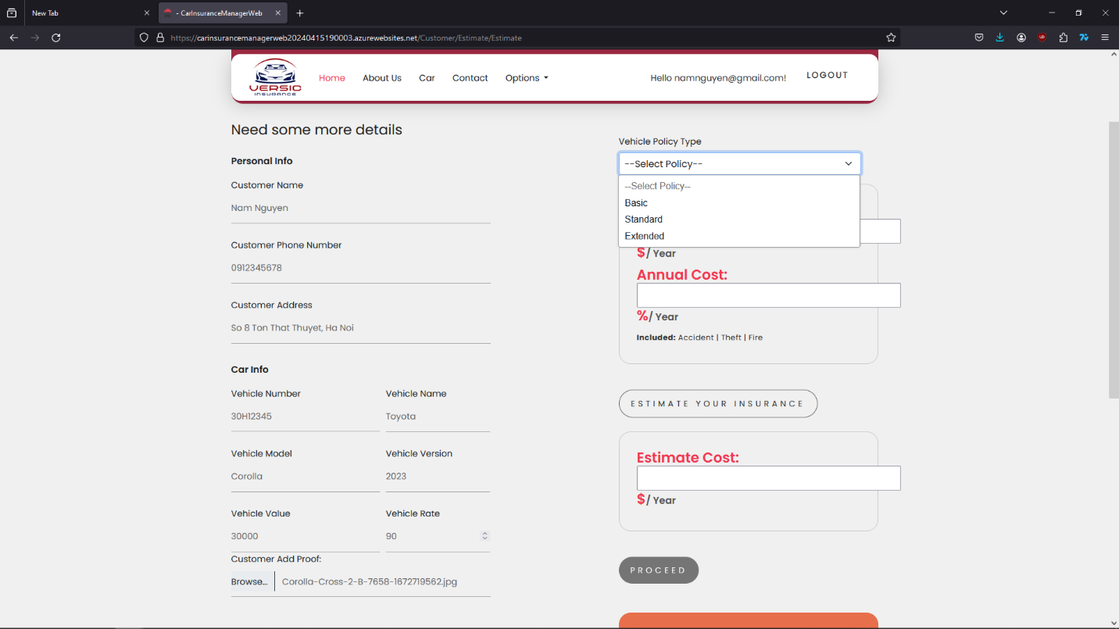

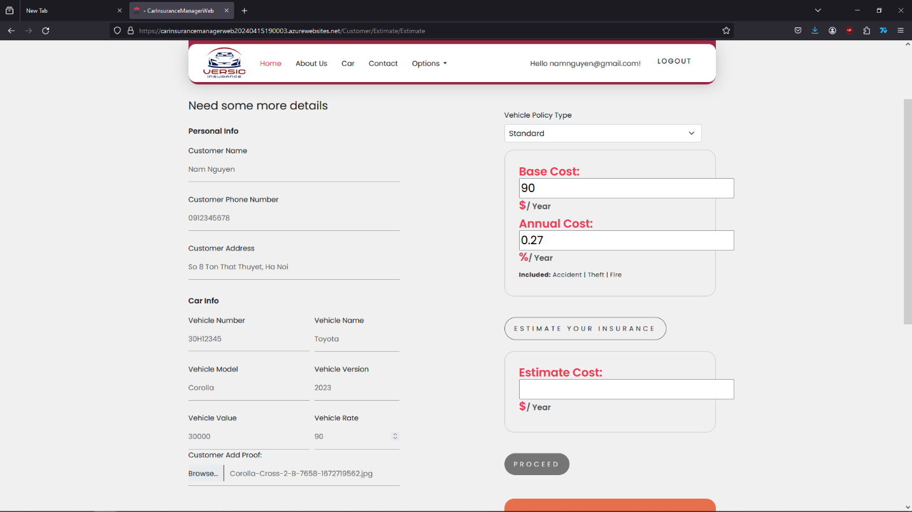

Press on the “Estimate your insurance” button to see the price of your vehicle insurance then click on “Proceed” to send the request.

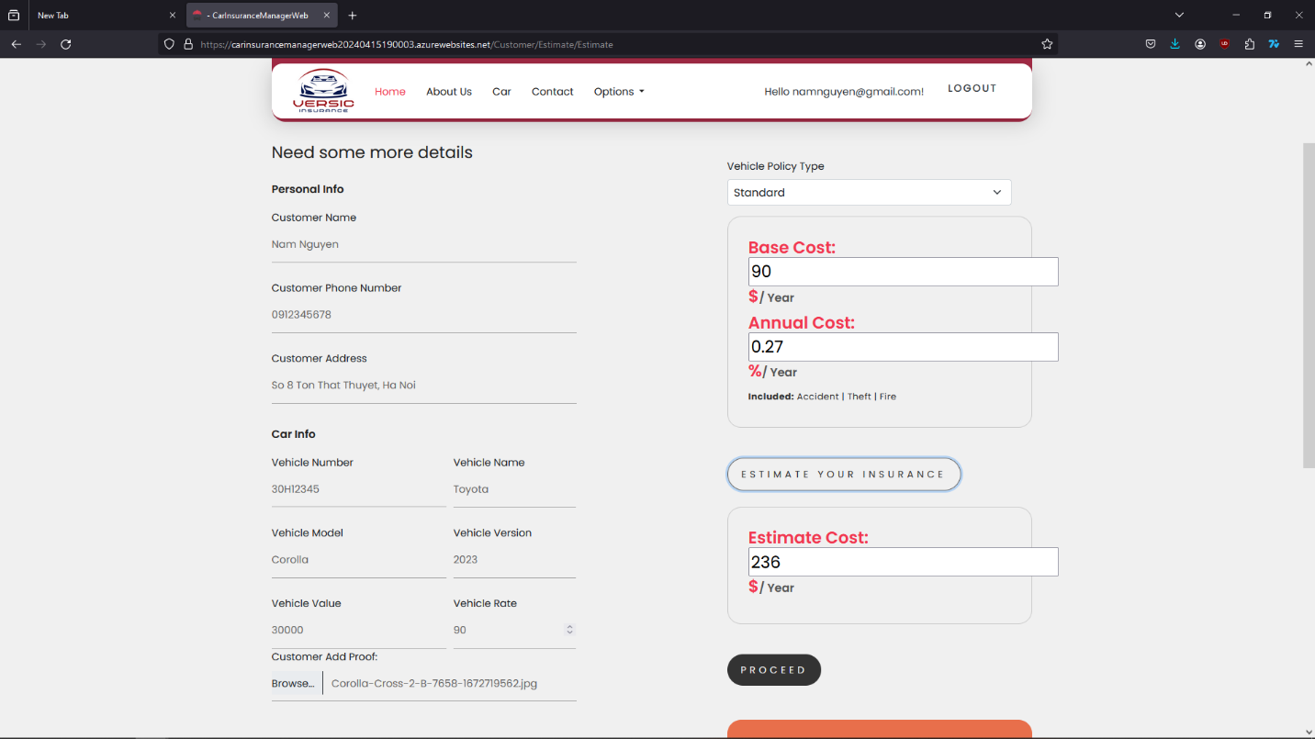

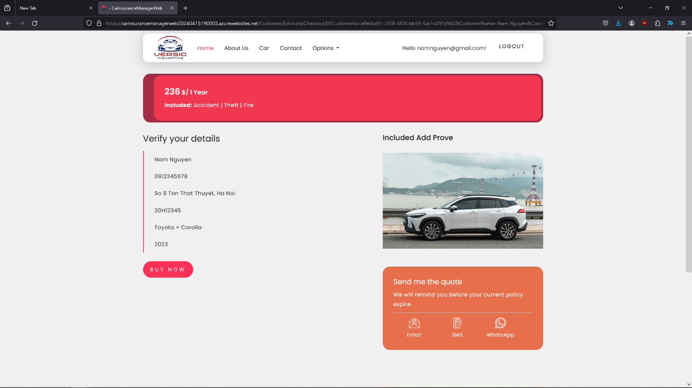

After customer check the information one more time, they can press on “Buy Now” if they decide to buy the Insurance. Request will be sent to the admin to checking and change status of the Insurance.

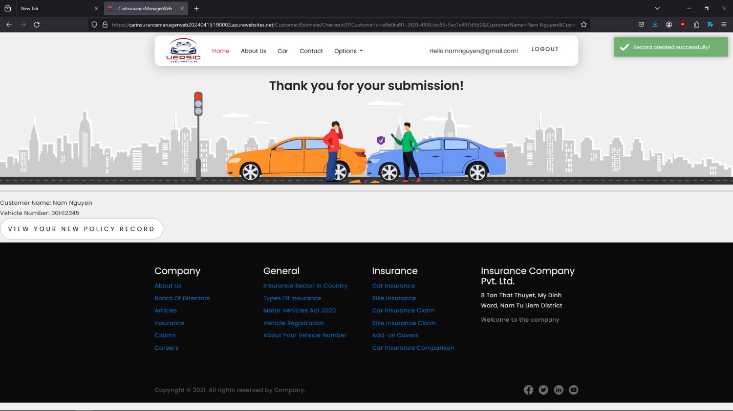

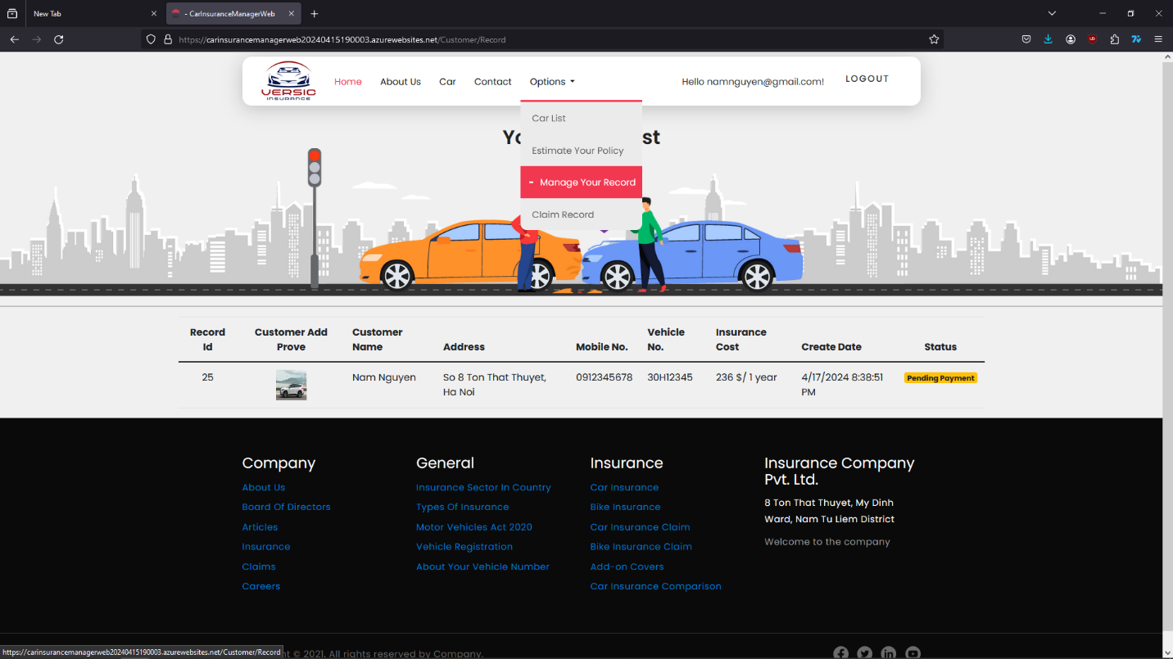

The customer can check the status of their policy in “Manage your Insurance”. If there is an accident happened to the **insured vehicle** and they need to get a Claim Fee, they can go to the section “Claim Record” to make a request.

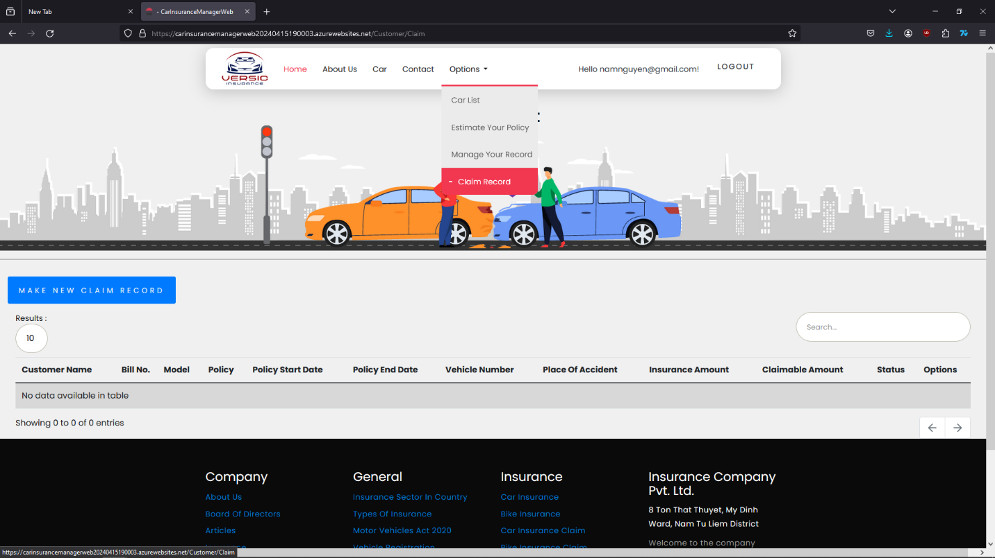

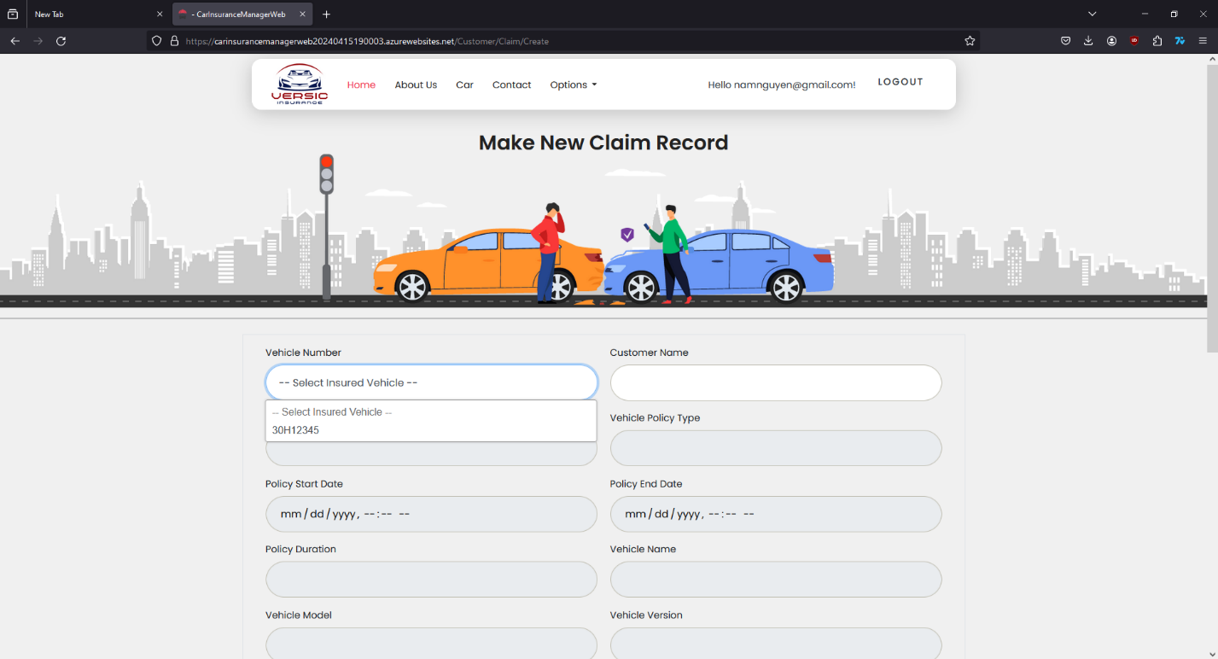

Customer simply choose the insured vehicle on the list and all the information of the vehicle will be automatically fill the form.

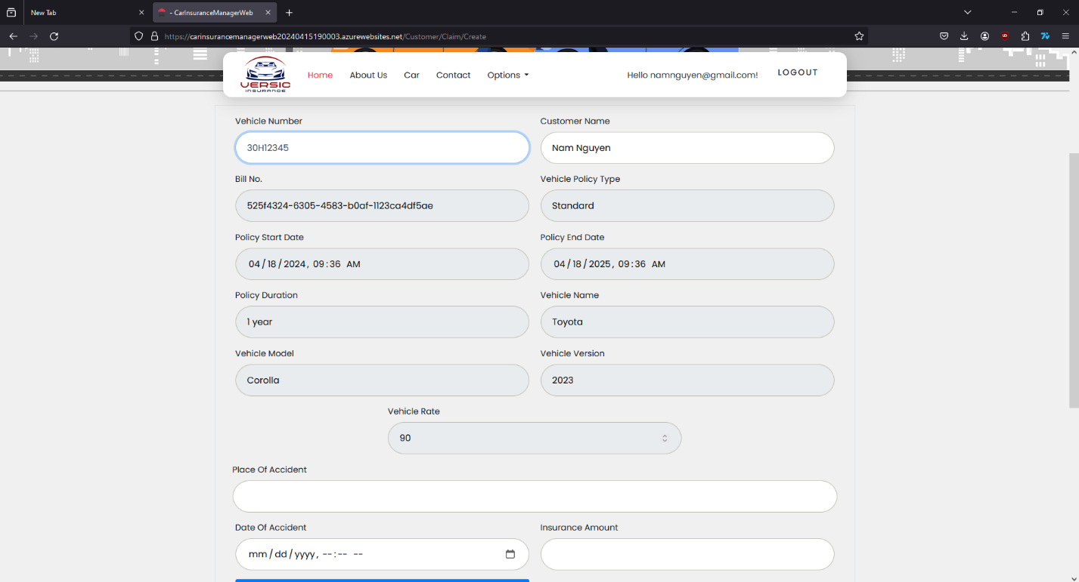

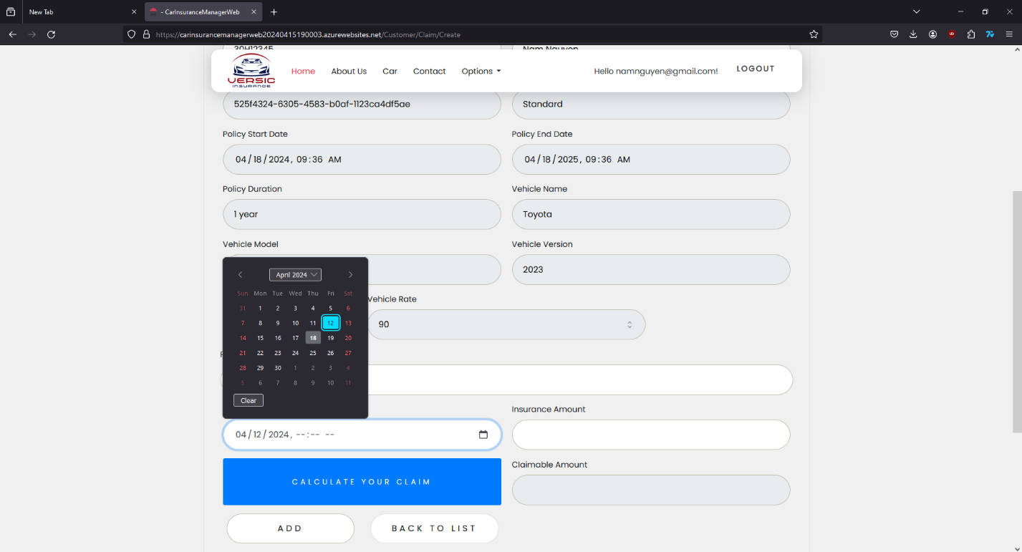

Customer just need to give the details about time and place when accident happened and the cost of repairing.

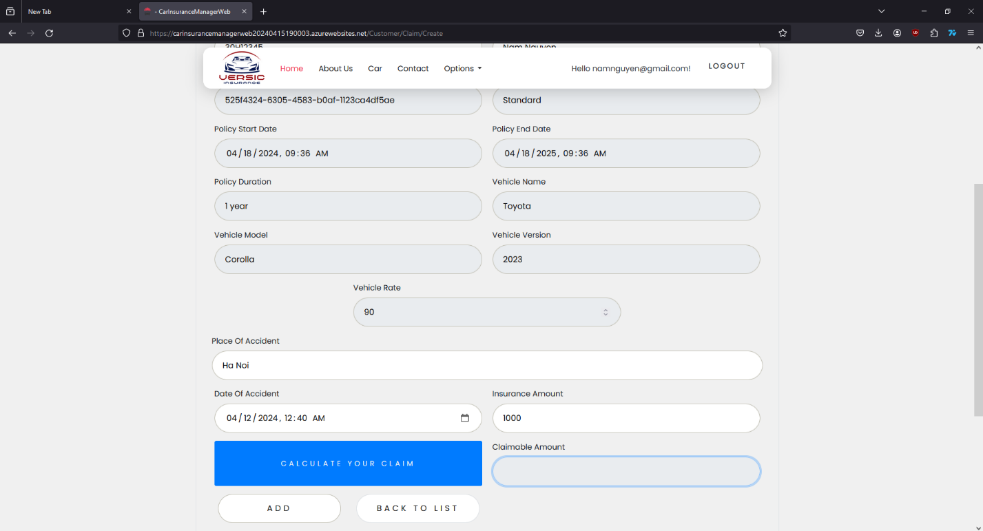

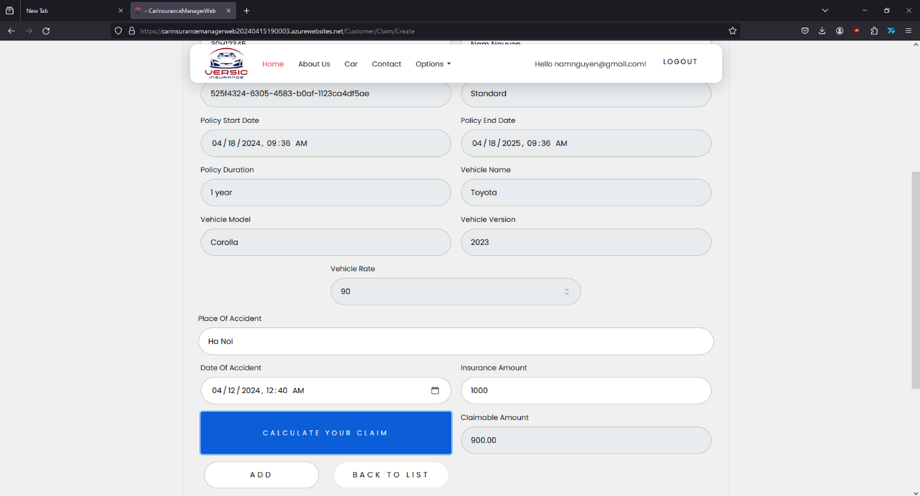

Press on “Calculate your claim” to see the amount of money pay back. Then press on “ADD” to add the request for Admin to check. Status of the request will show in “Claim Record” under “Option” section. Customer can edit or delete the request if they need to.

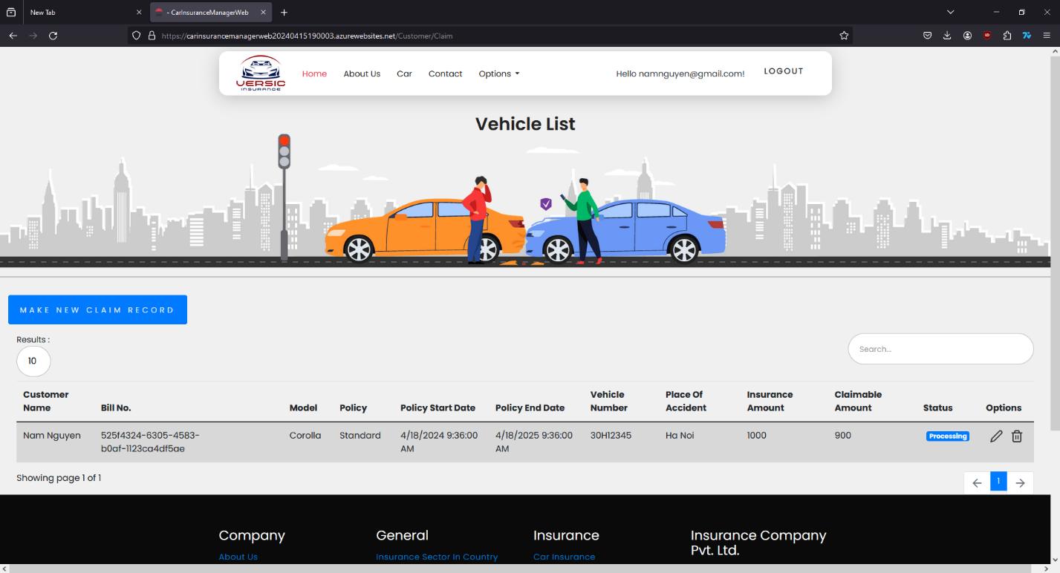

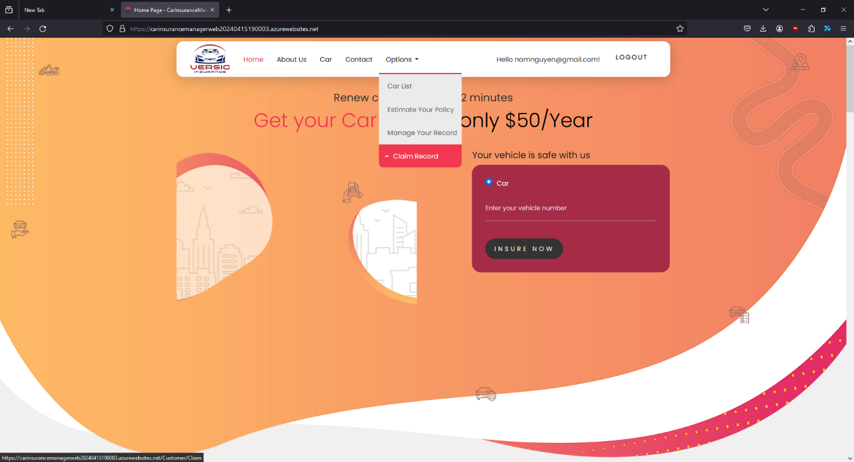

After Admin done with working on customer claim request, they can find the status of request in tab “Claim Record” if it’s done or has been canceled.

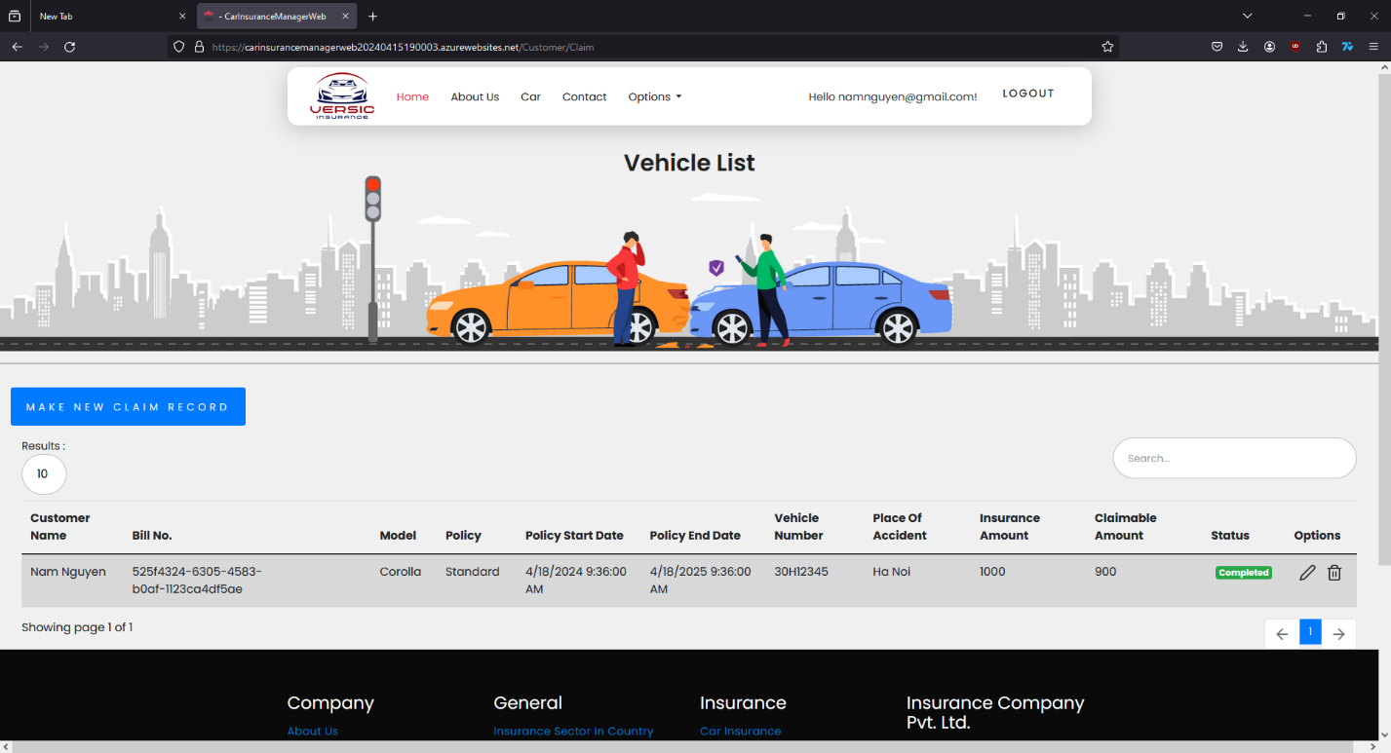

## **ADMIN GUIDE**

* Employee will be admin who can login with admin user name and password.
* He can perform all the admin functions as maintaining the policy records, claim records, payment schedules etc
* Following reports needs to be generated
  + Monthly sell of policies
  + Vehicle wise analysis
  + Claims report
  + Policies due renewals
  + Policies lapsed report

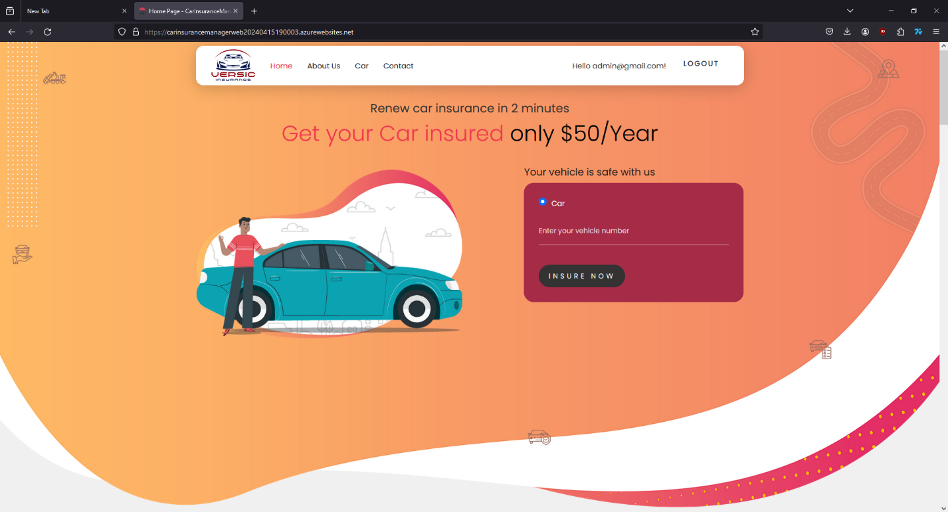

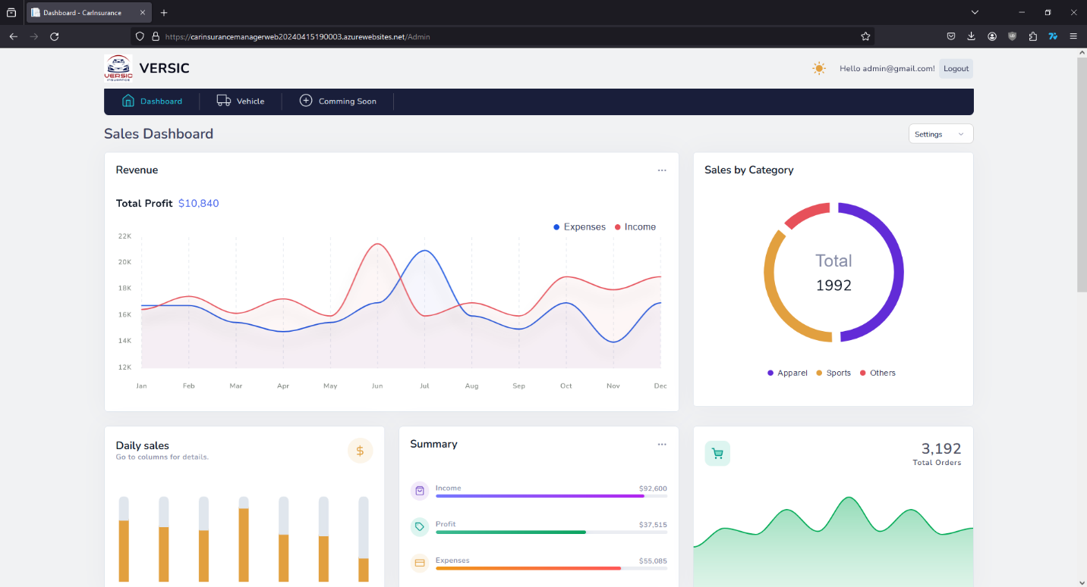

Admin has a different interface with Dashboard and charts with detail numbers.

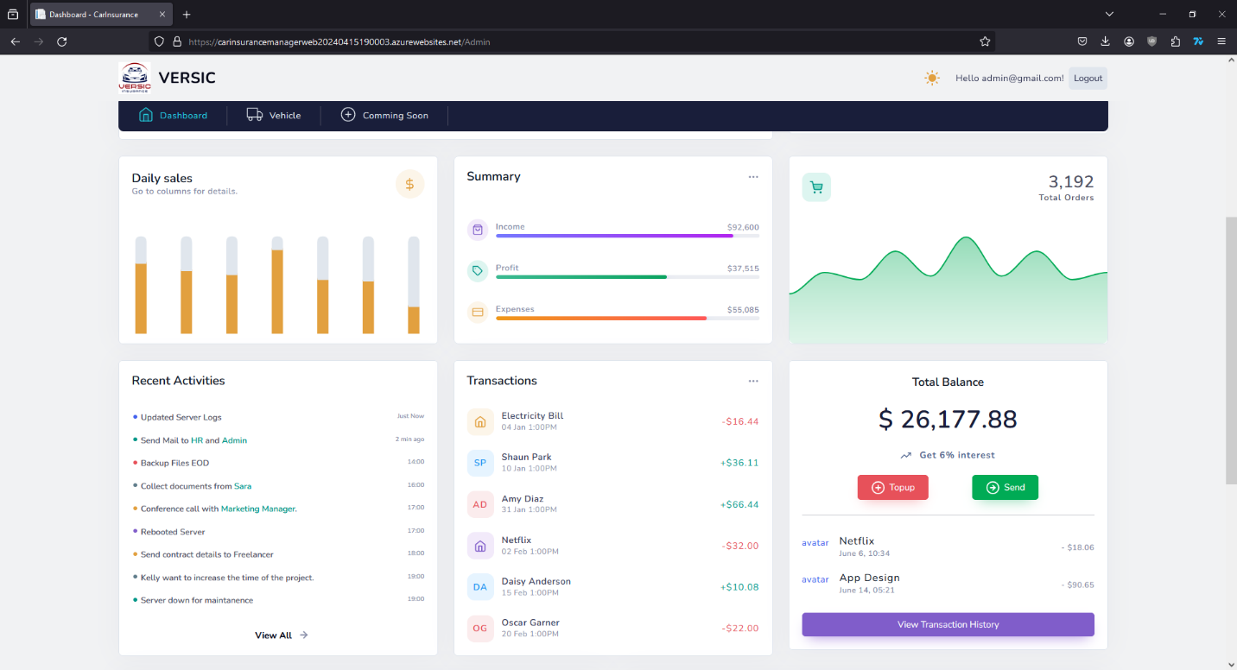

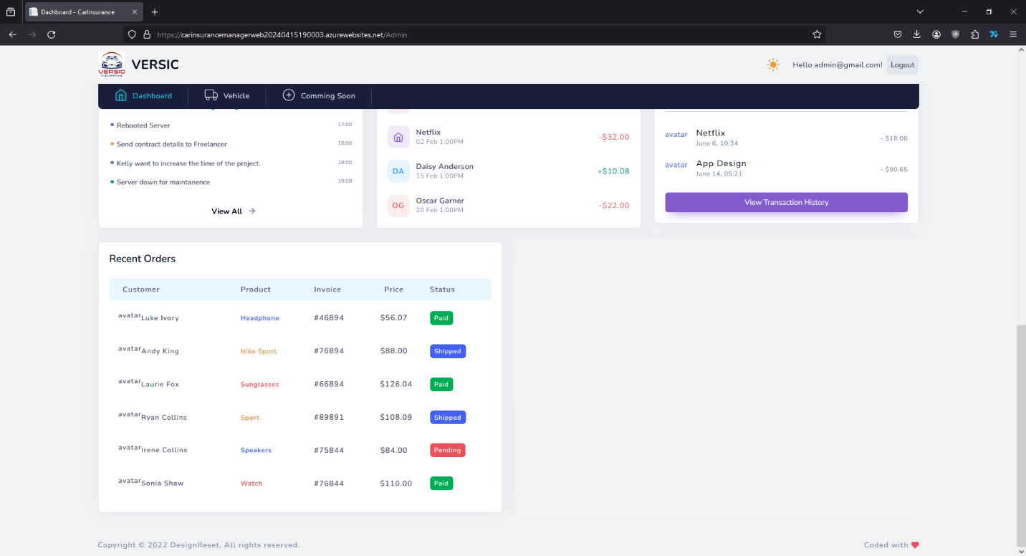

Main actions of the admin will be in the Tab “Vehicle”. Checking the vehicle list, manage types of Insurance, process the request, make the bill, check on the claim request,…

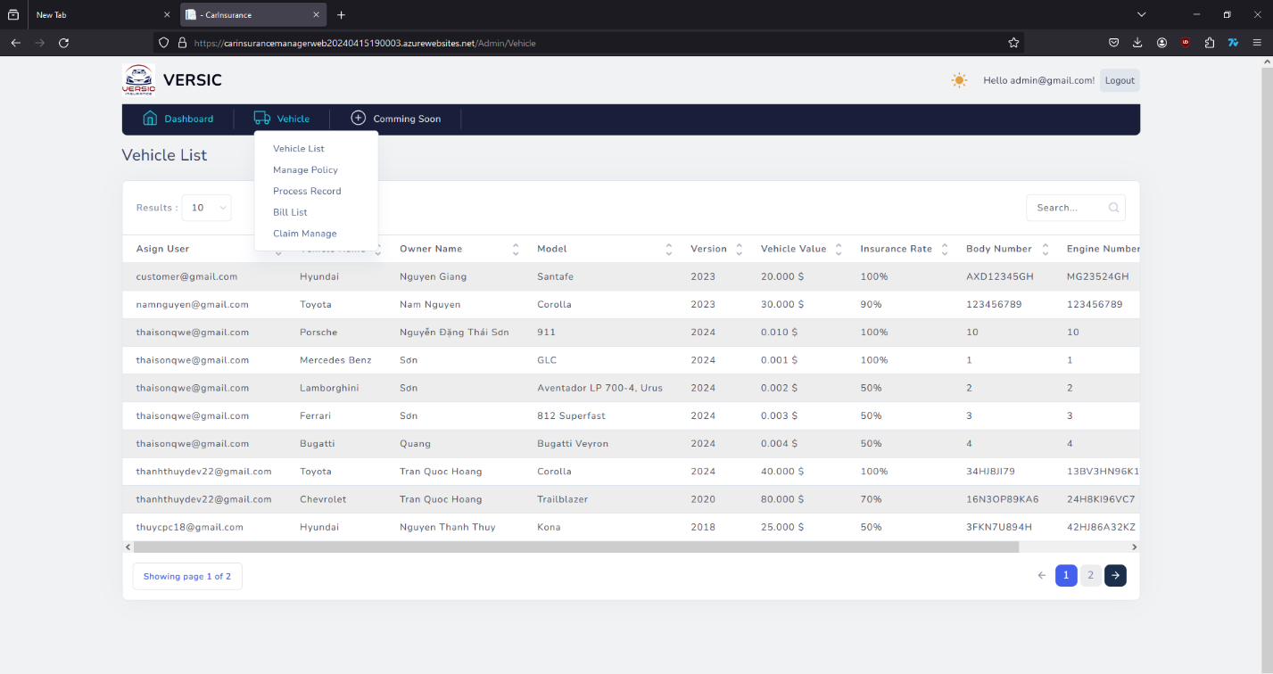

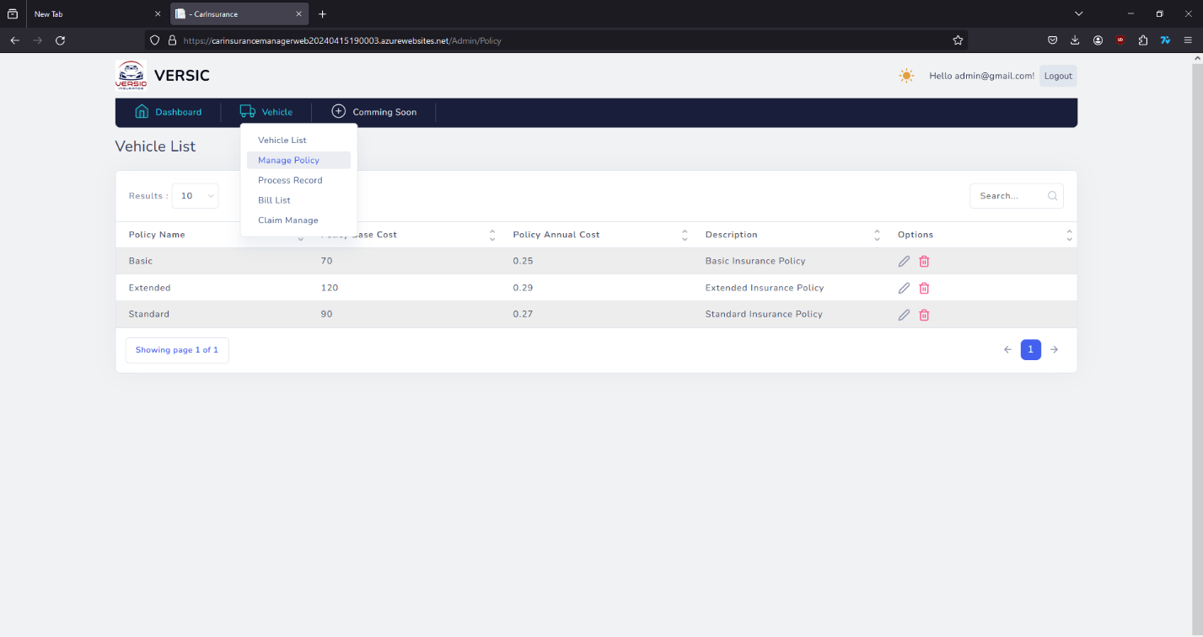

To process the buying request, admin go to “Process Record” and find the request to process.

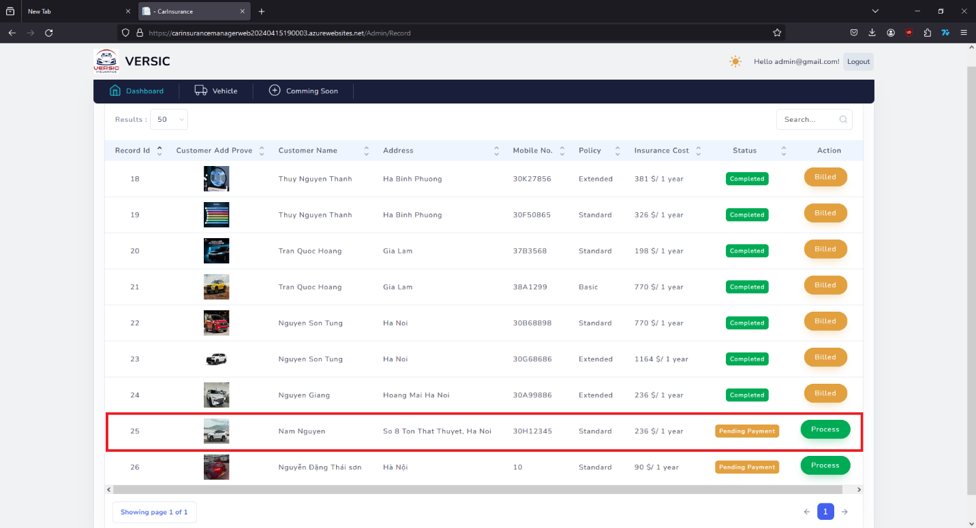

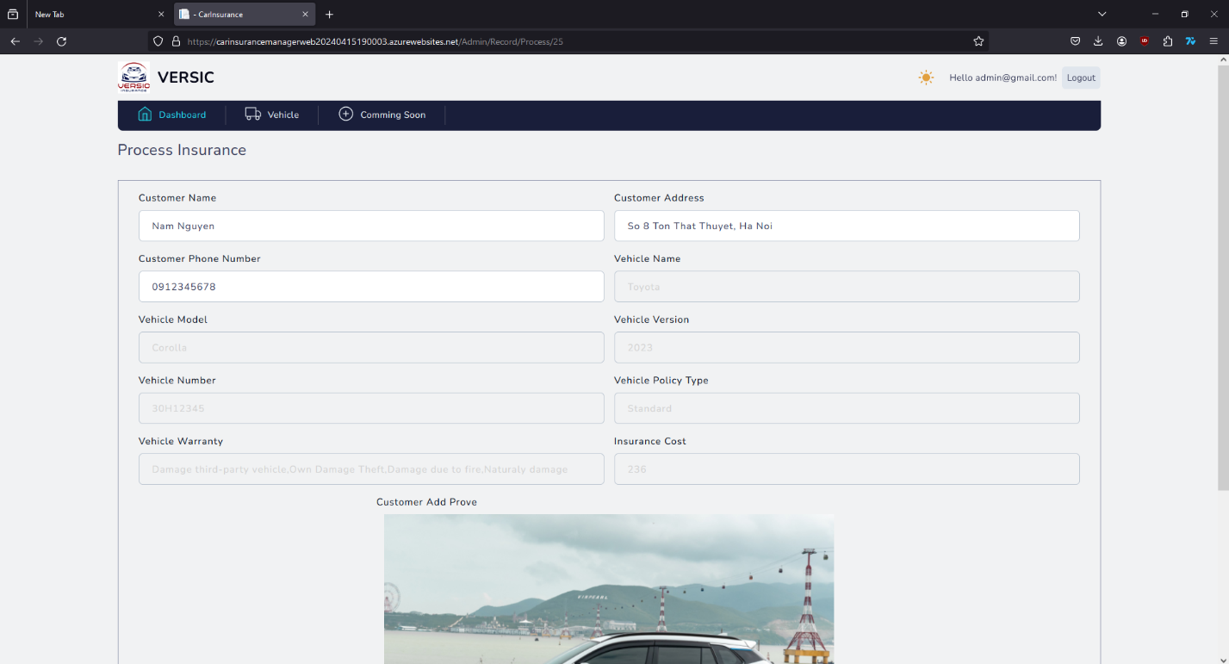

Checking the details of the vehicle then scroll down to “Payment status” and decide to choose which action need to be done.

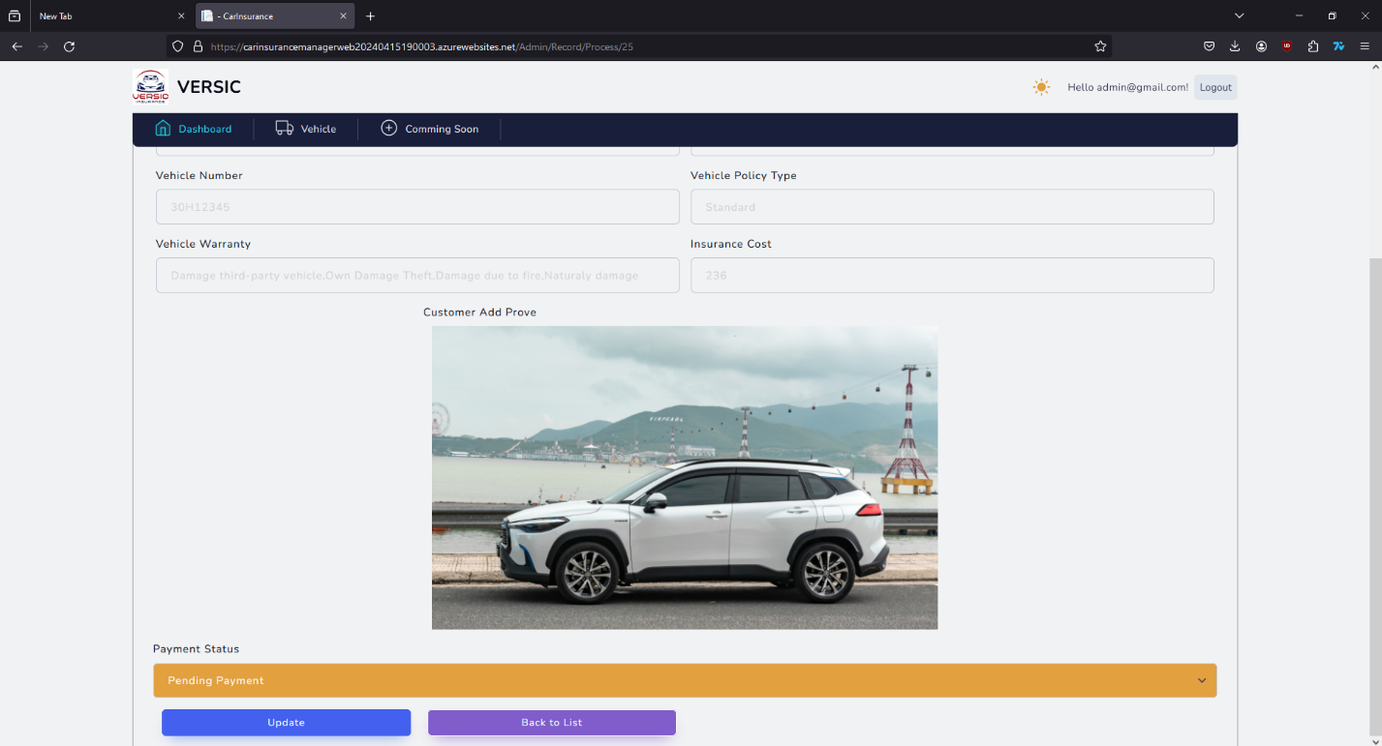

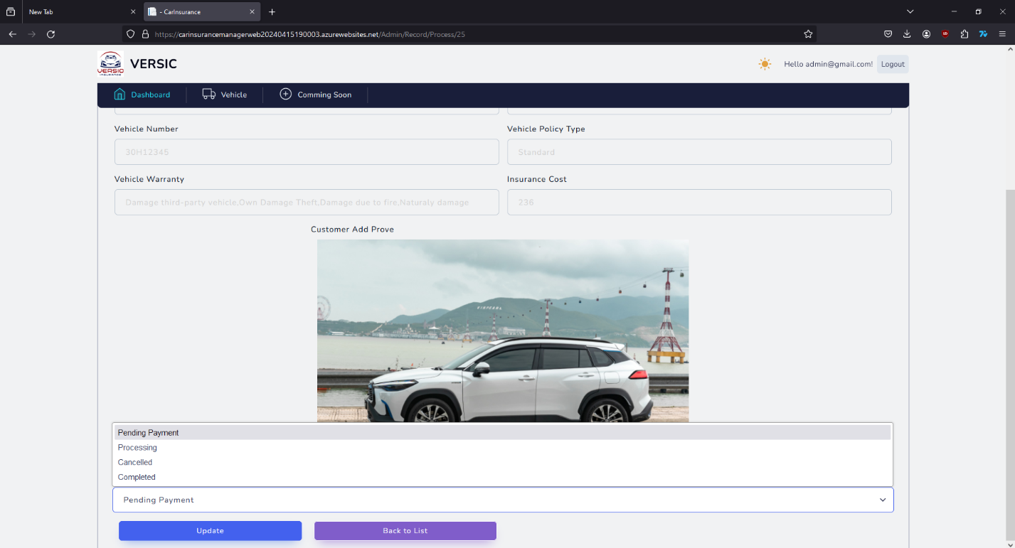

After change the status of the payment, press “Update” then the status will be updated.

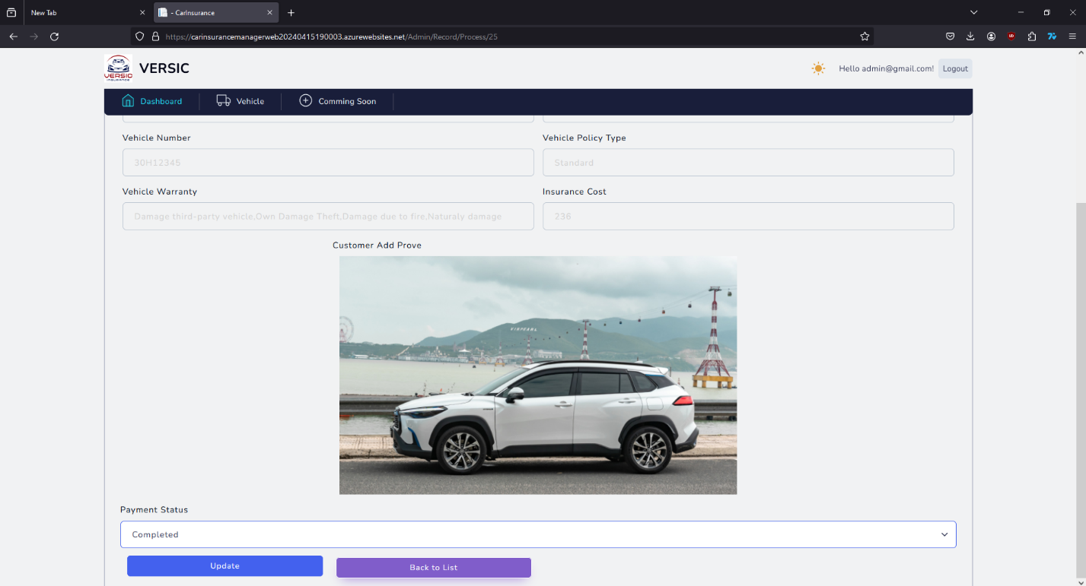

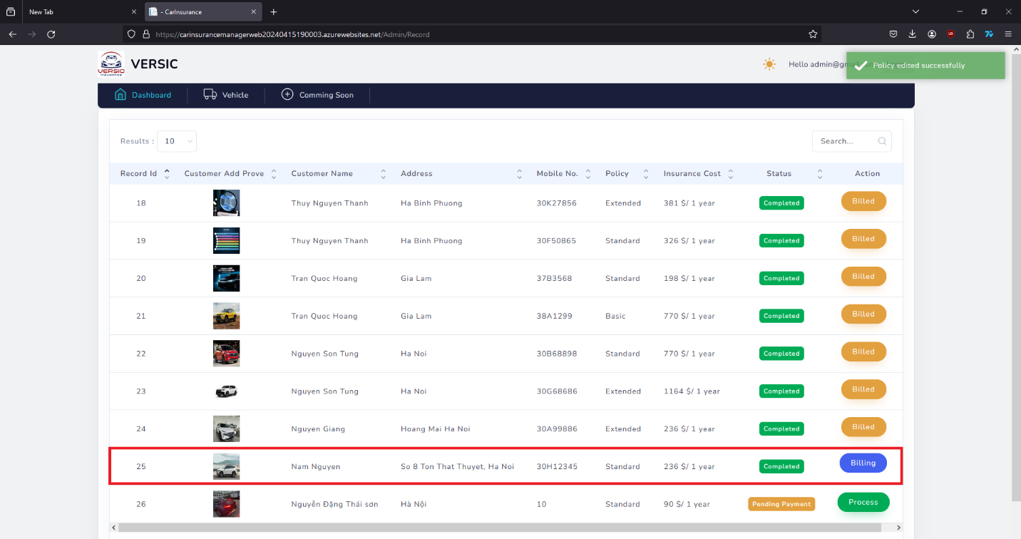

Admin can make a bill and send to the customer by press the “Billing” button.

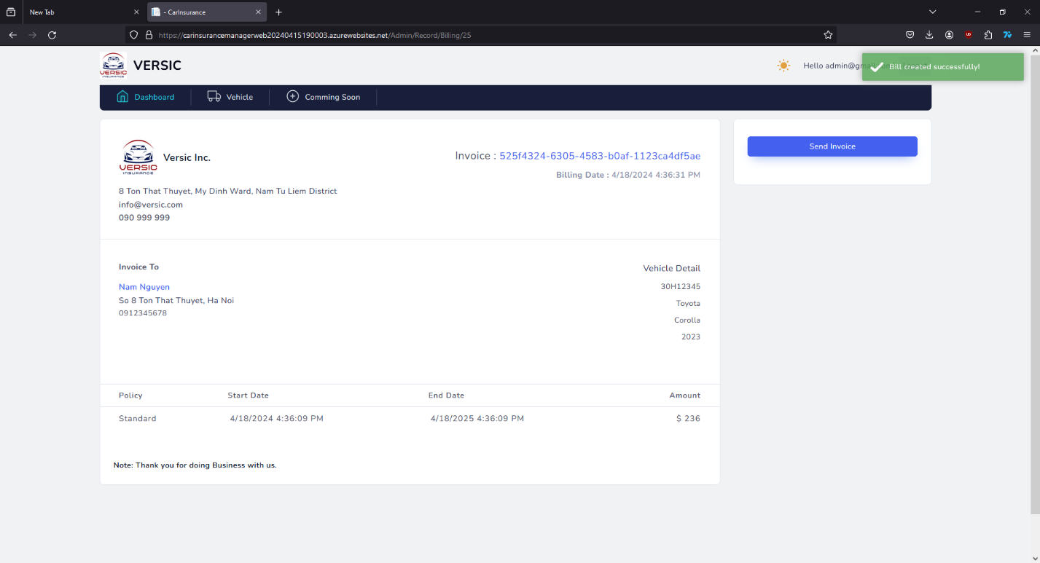

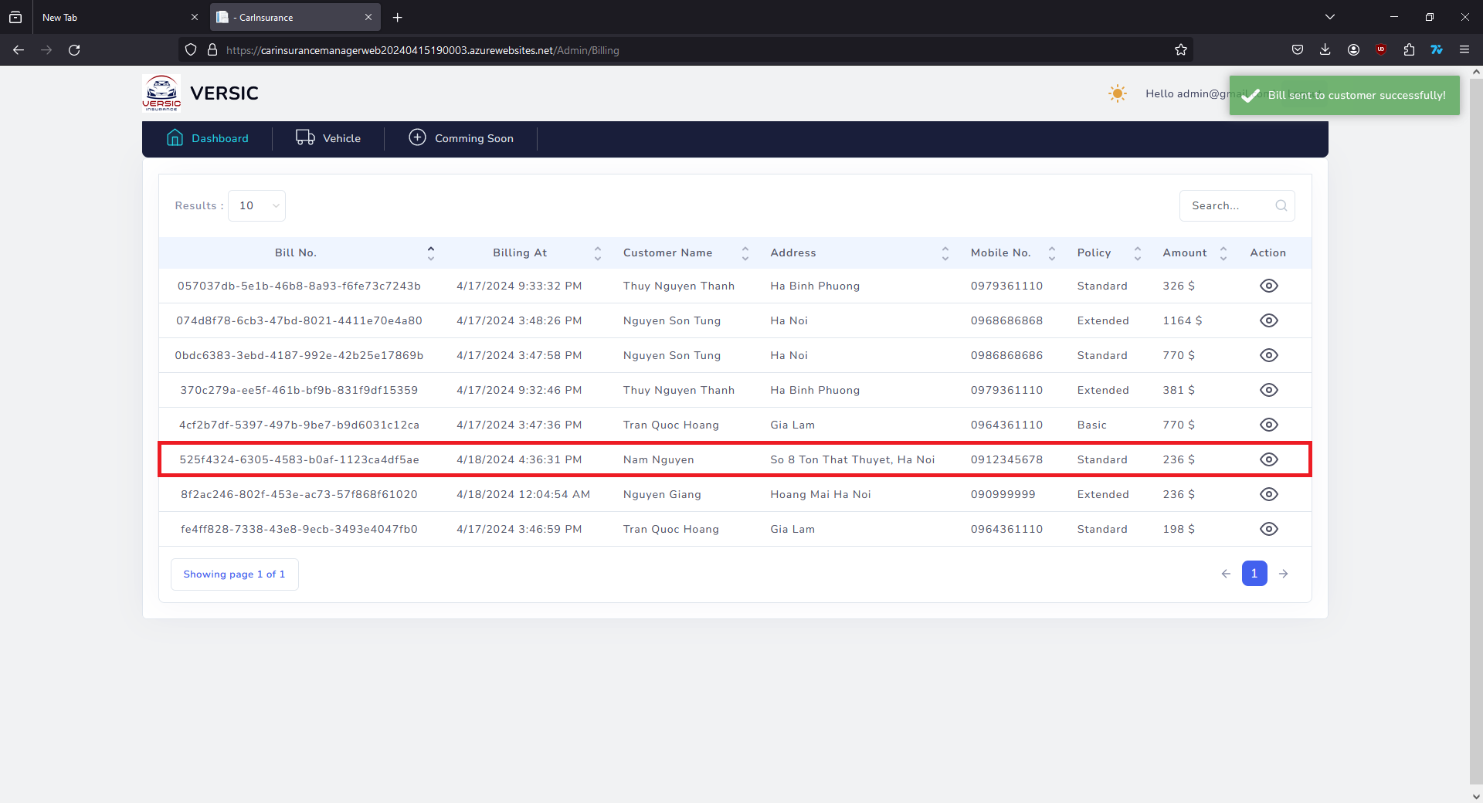

When Admin get a claim request from customer, Admin can go to the “Claim Manage” to take the action for the request.

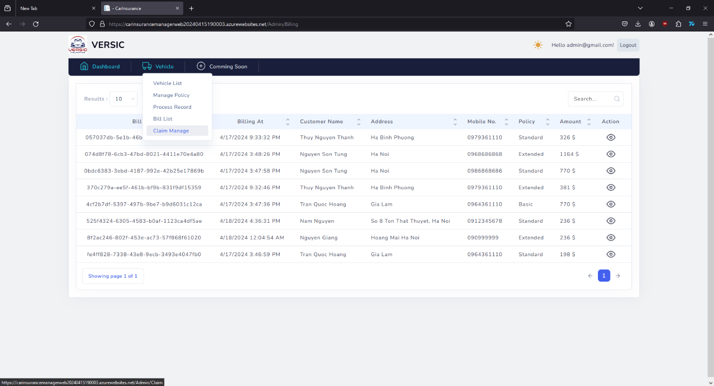

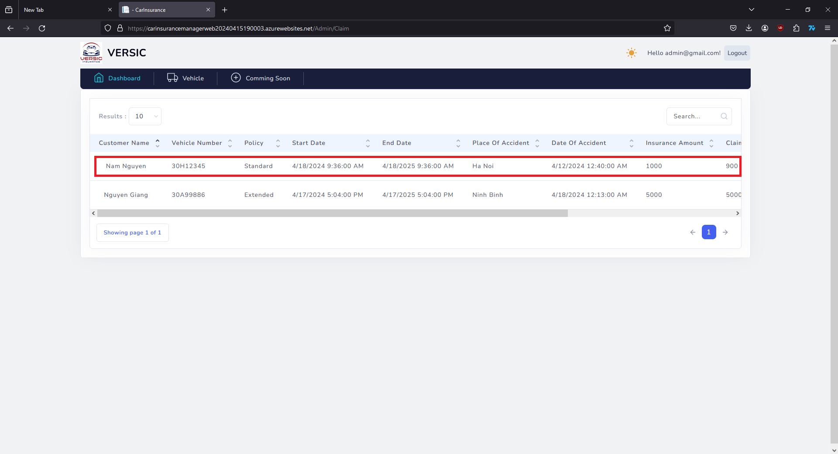

Admin find the request to process then press the button to working on the request.

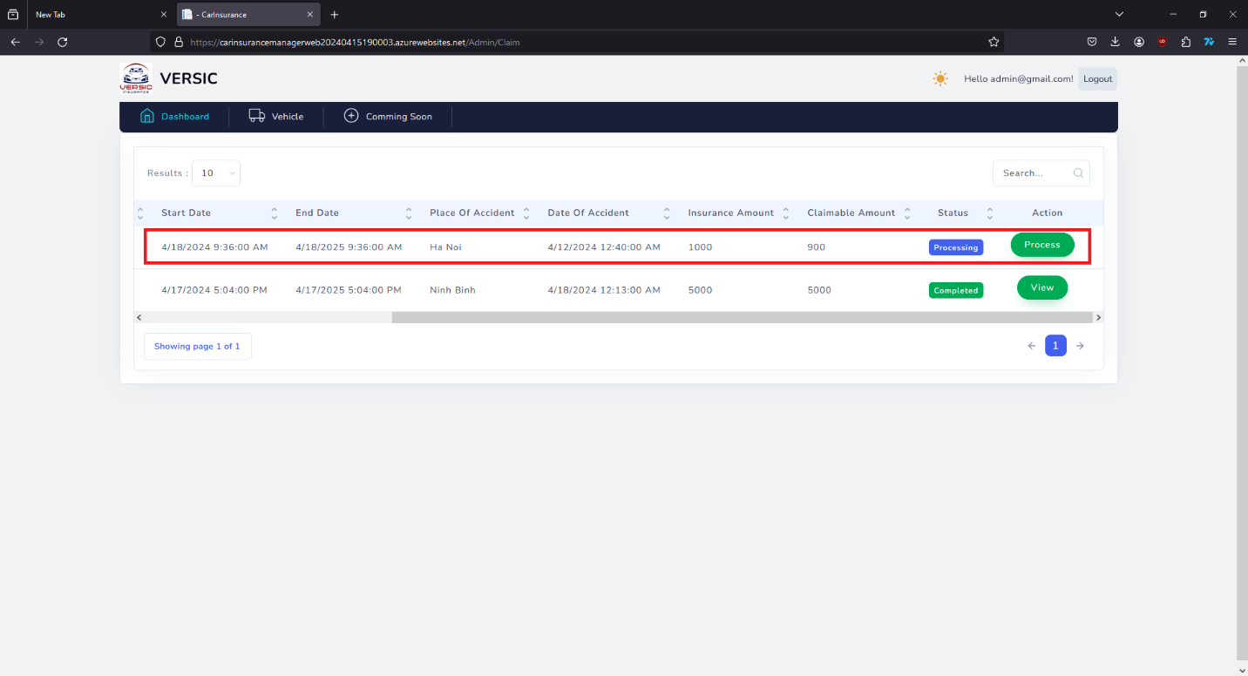

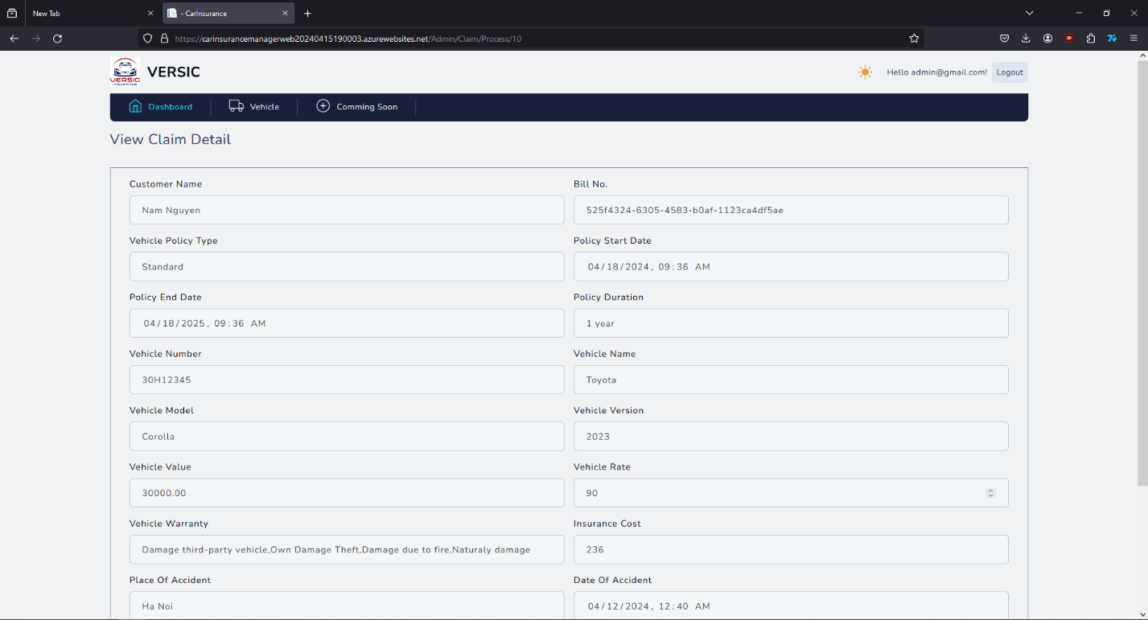

Admin will check on the information of the insured vehicle of the customer and decide to complete it or cancel it.

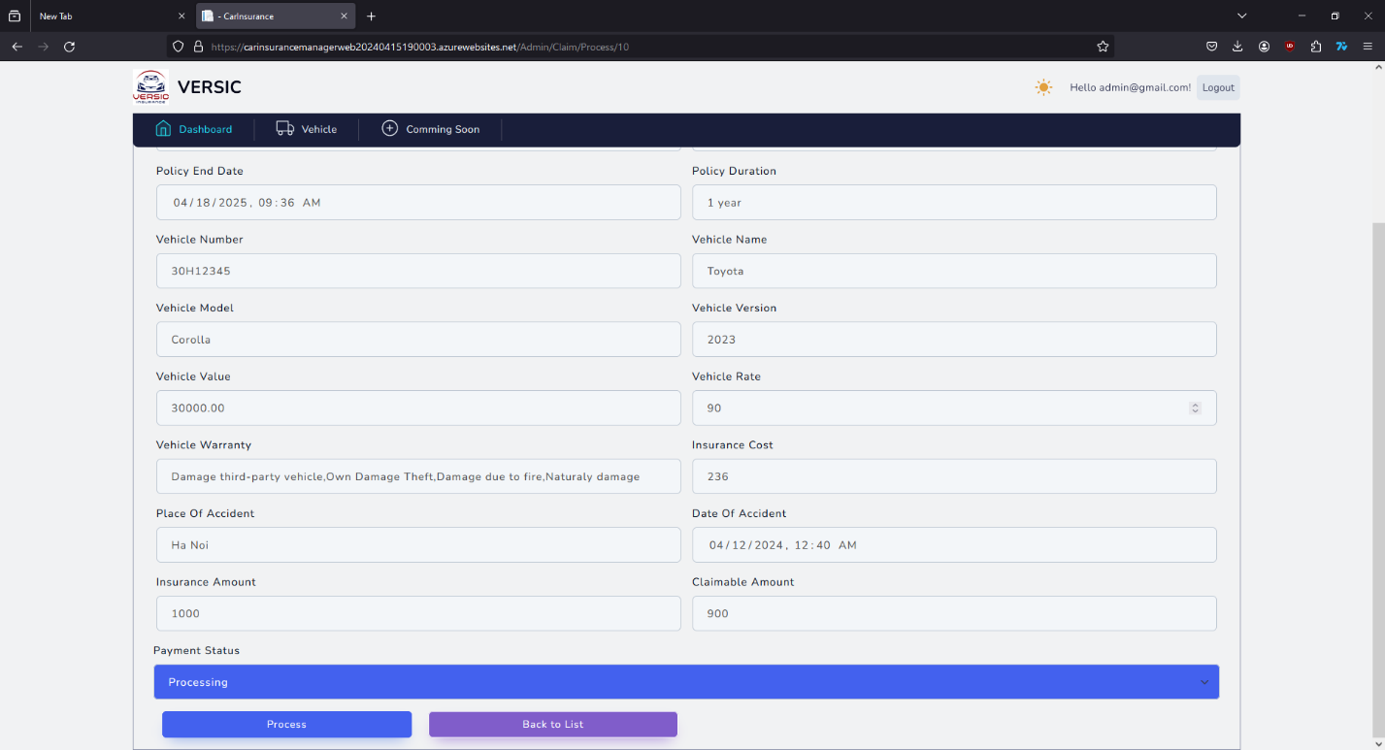

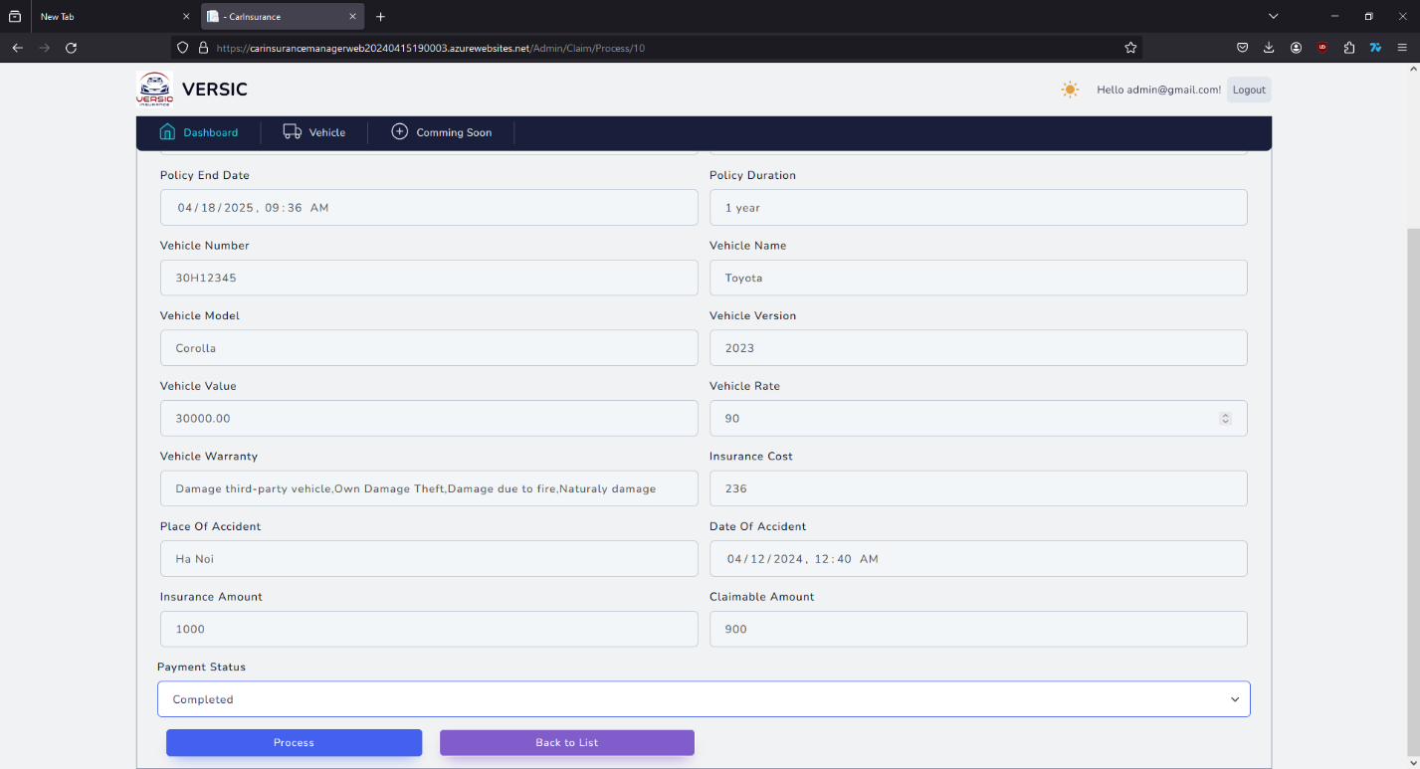

After decided action on the request press “Process” to update the status of the request.

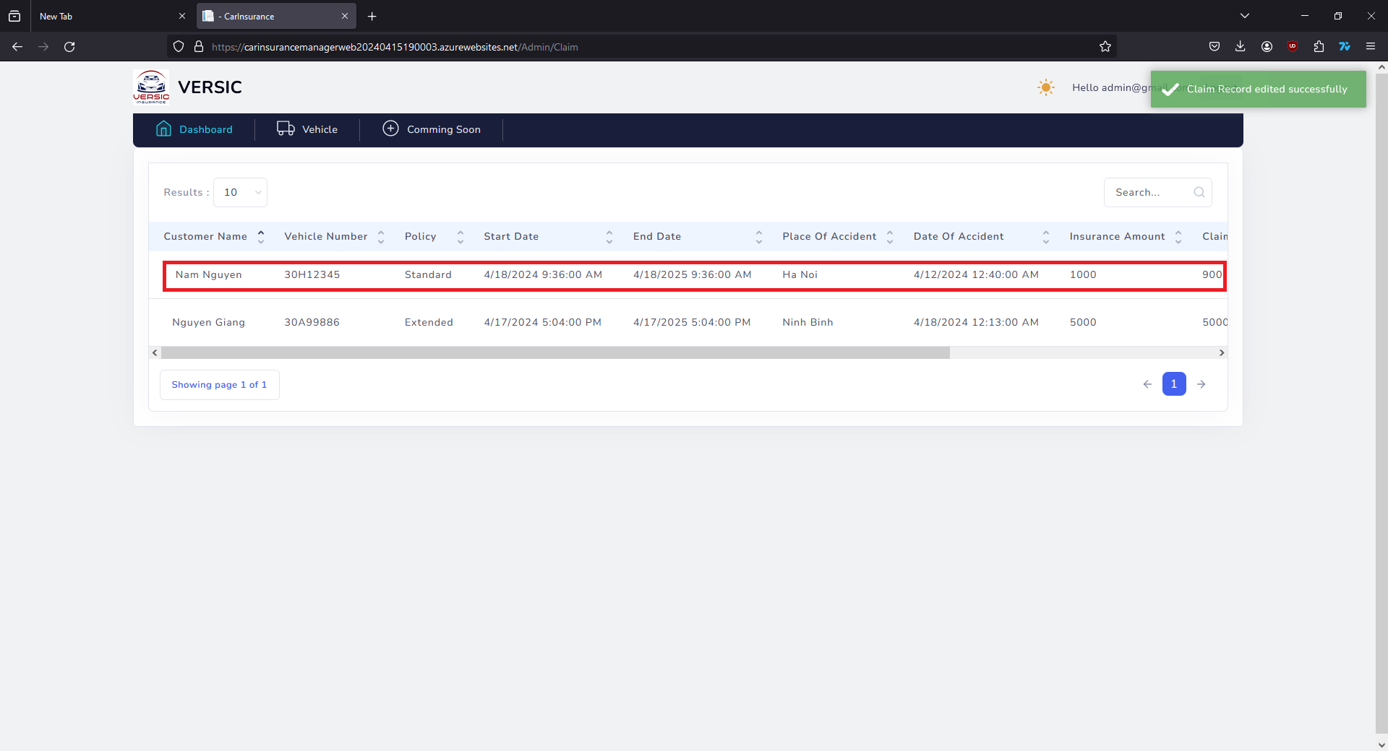

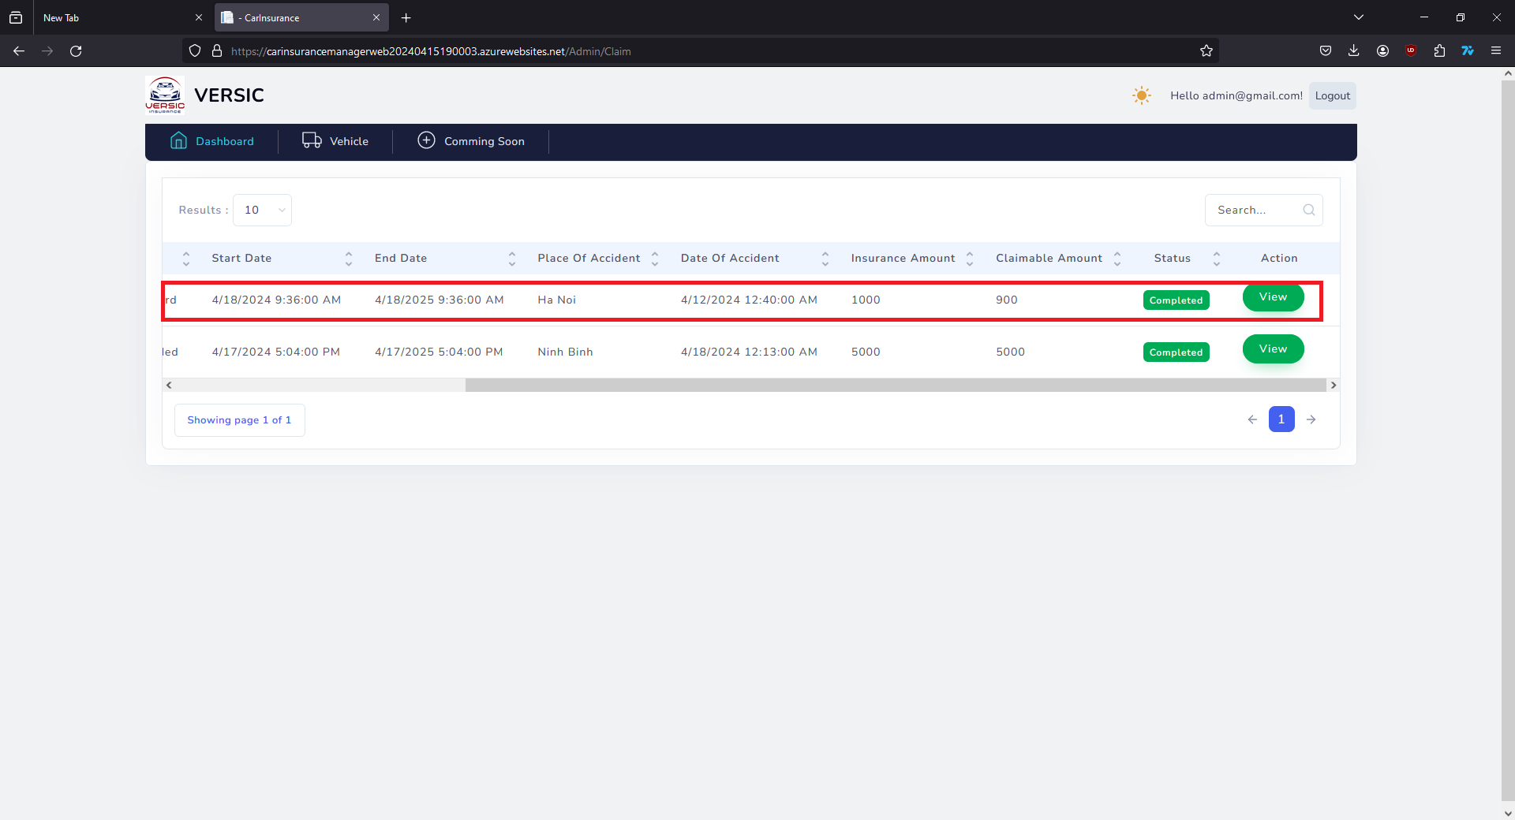

# Developer’s Guide

The solution name “CarInsuranceManager” has 4 projects:

* CarInsurance.DataAccess
* CarInsurance.Models
* CarInsurance.Utility
* CarInsuranceManagerWeb

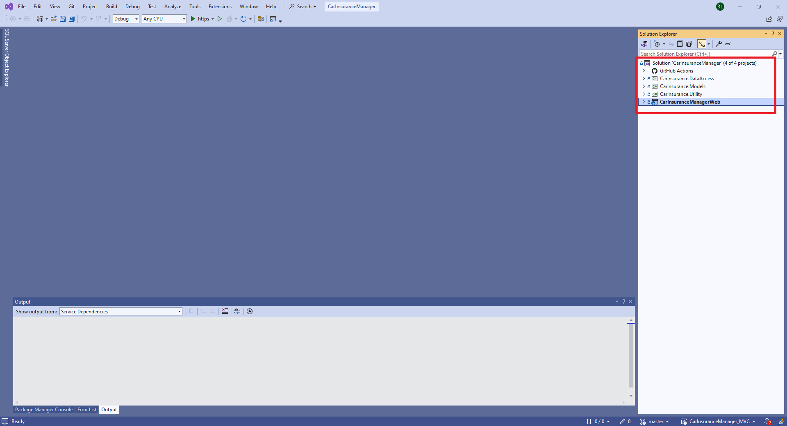

CarInsurance.DataAccess to communicate directly with Database SQL server.

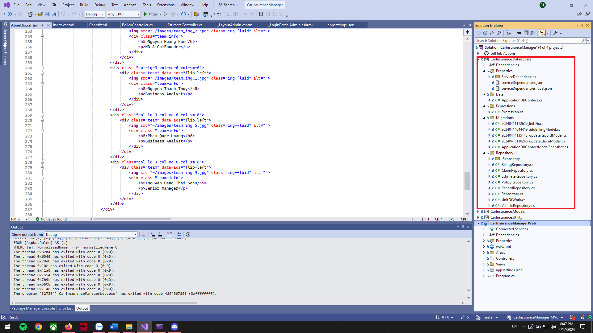

CarInsurance.Models has all the Models of the website.

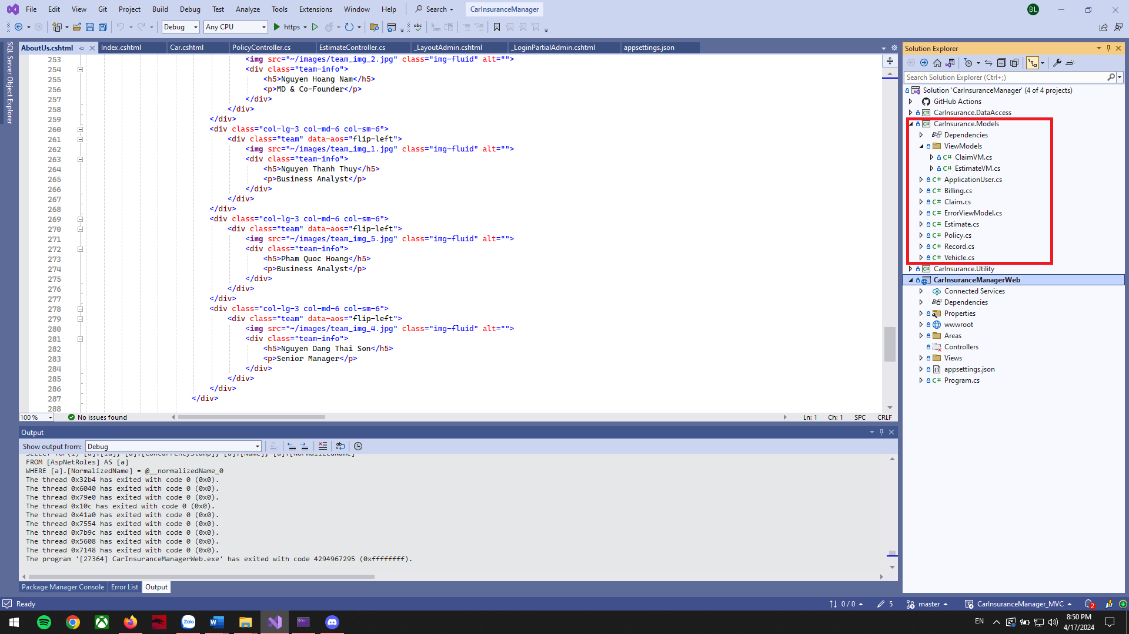

CarInsurance.Utility to contain other functions or dependencies such as sending email,...

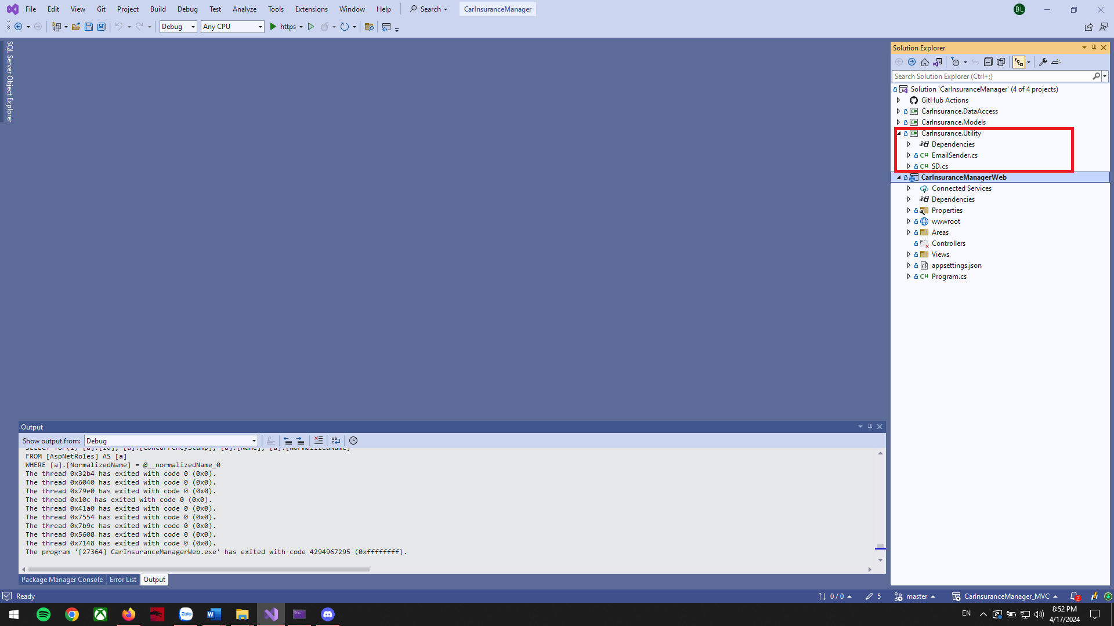

CarInsuranceManagerWeb is the main thing that contains controller to direct user requests and query data from the database via CarInsurance.DataAccess.

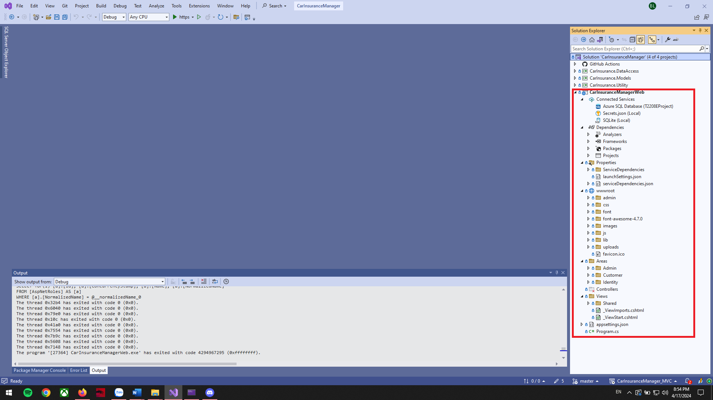

# Check List

|  |  |
| --- | --- |
| Design use-case diagrams | ✓ |
| Design workflow for project | ✓ |
| Create project, project file structure, readme | ✓ |
| Adjust the interface of Home, About Us, Contact | ✓ |
| Design Logo for website | ✓ |
| Design database schema, diagram for project | ✓ |
| Decide algorithms and calculation formula | ✓ |
| CRUD for Policy | ✓ |
| Adjust the interface of Car page | ✓ |
| Add features to add, edit, delete | ✓ |
| Add features Login, Register | ✓ |
| Estimate car insurance price depends on vehicle value, vehicle rate, policy base cost, policy annual cost | ✓ |
| Create a list of car brands and car types | ✓ |
| Deploy database to Azure | ✓ |
| Save policy records to the database, display customer records on the front-end and back-end | ✓ |
| Create bill after payment, Save bill to DB | ✓ |
| Create a claim-record, save it in the database, display the claim record on the backend, front-end | ✓ |
| Deploy project to Azure | ✓ |
| Design slide for project | ✓ |
| Write documents for the project | ✓ |
| Demo 20 records for website | ✓ |
| Video demo project | ✓ |

# Acknowledgments

We would like to thank our Mentor Mr. Hà Việt Sơn for his guiding role, wise counsel and vision in the creation of this website.

Many thanks as well to the team members, this website would not be able to be done without them, Nguyễn Bắc Giang, Phạm Thanh Thủy, Phạm Quốc Hoàng, Nguyễn Hoàng Nam, Nguyễn Đặng Thái Sơn.

|  |  |  |
| --- | --- | --- |
|  | Team member | Task |
| 1 | Nguyễn Bắc Giang | Main theme, Features, Functions, Modules, Deploy to Azure, Scripts, Database, Debug, Team Coordinator. |
| 2 | Nguyễn Thanh Thủy | Use-case diagrams, database schema, diagrams for project, Testing, BE. |
| 3 | Phạm Quốc Hoàng | Logo, Home page, About us, Products, Product details, Data (car list). |
| 4 | Nguyễn Hoàng Nam | Documentation, Guide, Video Demo, Slide, Contact us, Location, FAQ, Interface, Tester, Debug, Team Support. |
| 5 | Nguyễn Đặng Thái Sơn | Testing, support. |